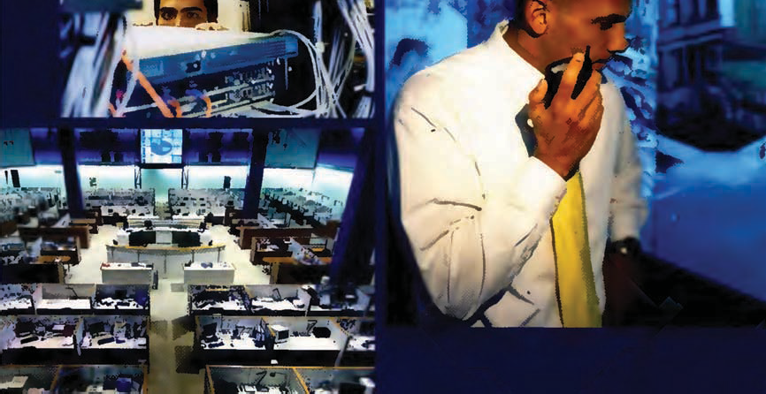

Contents

PAGE UNITTITLE TOPICS USEFUL LANGUAGE AND STRUCTURES

4 | Convergencein | Convergencein technology | Talkingabout change
 | Telecoms andIT | Convergencein business A converged future | Degrees of probabiUty in the future

14 Mobility Mobile devices Recommending
I
Mobile technologyin retail Explaining in simple terms
Location-based services
I

21 Software The software development process Future consequences
Software solutions Assessingopti:>ns

30 I
Project management Time periods

etworking Global infrastructure Sequencing

N
Enterprise networking Relative pronouns
Network management
I

39 Data centres Data Centres Talkingabout maginary situations
and secur ty Information security Giving instructions
Bankingsecurity
I

48 Services Managed services Comparing adjectives
Service Level Agreements The language of negotiating
Negotiatingan SLA
I

56 Media Television Assessingbus nesses
Media start-ups Describingplace
Website usability
I

66 Society Healthcare The passive
Surveillance Opinions
Technology adoption insociety

PAGE APPENDIX

75 Partner Files
79 Answer key
86 Transcripts

Convergence in Telecoms andIT

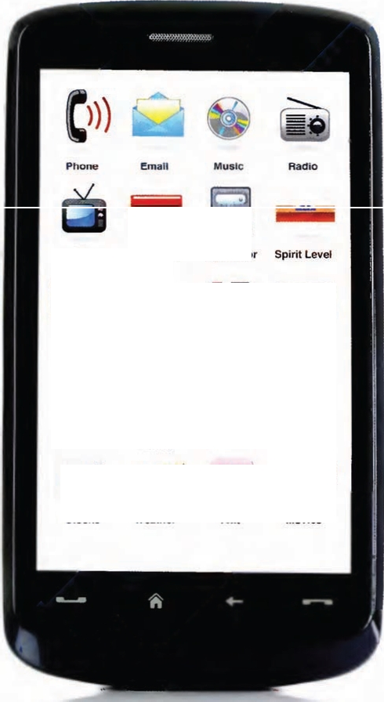Work with a partner. Make a list of all the things some of the latest mobile devices can replace. Look at the screen of the device below for ideas.
STARTER

cl))
Phone eman MUSIC Rad o
. iii
B
TV Cale.ndar Calculator Spirit Level
· l. I ..)
I
Maps Games Camera Photos
,,.. .......

ffi
i\'.41f1!!: ";

Time Business English Tests Internet Finder
•

Stocks Weather T•xt Movies

UNIT 1 Convergence in Telecoms and IT I 5

CONVERGENCE IN TECHNOLOGY

1 Read the blog post below and underlinethe questionsit asks.

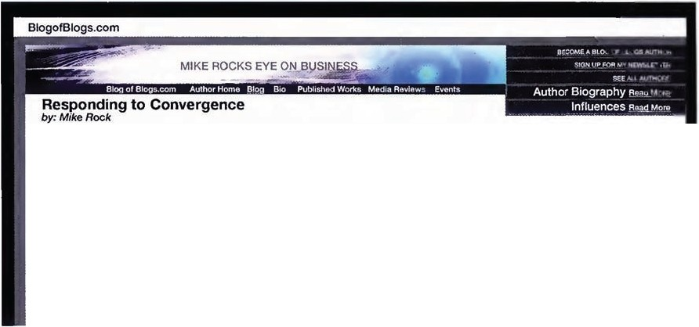

Convergenceis creating new businesses and forcing existing businesses to adapt quickly or die. We are seeing the convergence of telecommunications,IT & Media; the convergence of fixed & mobile services and convergence at device level.All of these trends are creating new markets and making other equipment, products, services and even whole companies rapidly obsolete. For technology manufacturers or service providClS, deciding which markets to base your future on becomes a challenge with serious consequences. Should BT or AT&T provide home 1Vservices to replace their declining telephony revenues? Should Kodak integrate a mobile phoneintoIts cameras or just give up?
Does Microsoft still need to sell boxed software when you can download applications onto a smart phone?
Does everyone have to have a mobile offering or have no future? When the communication of voiceis just another software applicationwhat do equipment manufacturers like Nortel or Alcatel-Lucent do? Google just does search,right?
Collisions within the telecoms, ITand media sectors are occurring now on a daily basis. Like any busy crossroads, there are
going to benear misses and head-on crashes.As ever,the survivors will bethe companies that understanc their customers, and are agile enough to quickly respond to all this change.

Add New Comment Sendj"o A_Friend ASS Bookmark with:,ia 1 !Cl.v

Discuss the questions with your partner.

2 Write a commentin response to this blog post.

3 Complete the tab e below with the names of the companies that providedyou with the different servicesin the past and in the present.Then try to predict which company mightprovide the
servicesin the future.

Seven years ago
Now
In seven years
Fixed phone Mobile phone
Internet TV

When you havefinished,compare your answers withyour partner.

TECH TUTORIAL

3G,4G
New generations of mobile phone standards, allowing mobile network operators to offer advanced services Ethernet
A very high bandwidth data networkingtechnology used by companiesin LANs and increasingly WANs GSM =GlobalSystem for mobile communications A worldwide standard for mobile phones making
phones from one operator compatible with a different
operator inanother country
MPLS =Multi-Protocol Label Switching
A data networkingprotocol and service that can carry different kinds of traffic -voice, data, video etc.
Opensource
Software that is made available to developers and users, licensed to encourage re-use without charge.
Saas = Software asa Service Wi-Fi
A technology providingwireless transmission of data over a short range (for example,in a house or office)
Wi-Max
A techno logy providingwireless transmission of high speed data over a large area (for example,a city)

6 I UNIT 1 Convergence inTelecoms and IT

4 Read the magazinearticle about trends in Telecoms and IT. Match the Industry leader to their area of expertise.

1 Peter Wilson
2 Jenny ane
3 Sanjay Ravi
a software b telecoms c hardware

STATE OF PLAY
To celebrate our 10111 anniversary, we invited industry leaders to share their thoughts about the changing world of Telecoms and IT. To find out what they think, read on ...

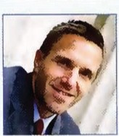

Peter Wilson
The world is now plugged in, and all over the world, allowing companies countries are connected up using to manage and communicate with a mixture of terrestrial networks, their operations wherever they may be. undersea cables, satellite and micro­ A reason for this 1as been the fall wave communications, Wi-Max and In bandwidth costs. and broadband is Wi-Fi, GSM and 3G. The move from getting cheaper and cheaper. Services packet-based services to the internet can now deliver tens or even hundreds protocol means everyone expects to of megabits of bandwi·:lth into individual communicatevoice, dataandvideofrom homes for much less money than a anywhere to anywhere, globally. The 64Kb line that a whole factory might
availability of wide area data services haveused to run its operation only afew suchas MPLSand Ethernet have spread years ago.

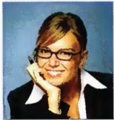Jenny lane
In 1965 Gordon Moore stated that the number of transistors on a chip would double about every two years. And that has more or less remained true since then. As we write,asingle chipcan hold about 1 billion transistors each making 3 billion binary calculations per second.
There has' been a huge increase in the volume of data and data storage capacity required for this; secondly,

there has been a significant decrease in the size and power consumption of hardware and finally manufacturing costs are falling significantly. The resultis that there are more and more powerful computers in our lives, and even handheld devices can store gigabytes of data holding thousands
of MP3 music files or hundreds of films.

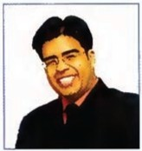Sanjay Ravi

The internet is changing the way we access, buy and use applications. We go online and download the software we want onto our computer, like any other digital product. Increasingly we don't even have the software on our hardware, but visit an internet site and use that application as a service. The use of this Software as a Service (SaaS) model means that we may not need such powerful computers inthe future.

We have seen the impact of off­ shoring and the rise of India as the world centre of software development and application management. We are also seeing some of the smartest applications and services coming out of people's bedrooms; more and more experts are producing Open source software, which is becoming more and more popular, creating a real threat to the big corporations.

UNIT 1 Convergence in Telecoms and IT I 7

5 Read the text again.Say if the following statements are TRUE Cnor FALSE (F) accordingto the text.

According to Peter Wilson:
- most countries are connected up with undersea cables. D
- many countries have unreliable mobile phone networks. D
- recently bandwidth costs have risen dramatically. D
According to Jenny Lane:
- Moore's predictions have been fairly accurate. 0
s a typical chip can now hold 3 billion transistors. 0
- both data storage capacity and power consumption have gone up. 0
According to Sanjay Ravi:
- fewer people are going to computer stores to buy software. 0
- Saas will require ordinary users to have more powerful computers. 0
- software development needs the support of a big corporation to succeed. 0
6 Match the words on the left with the words on the right to make pairs of words that often go together. The word on the left must go with all three words in the set. See the example.

1 | access | a | chip, wafer, valley
2 | downloa | b | an application, a network, an account
3 | go | c | online, offline, on holiday
4 | mobile | d | phone, telephony, broadband
5 | silicon | e | a file, an image, a demo version

7 Complete the sentences using pairs of words from exercise 6. Make any changes that are necessary.

1 Everyone has ,so payphones are becoming redundant.
2 Many internet entrepreneurs from in California are now turningtheir attention to alternative forms of energy.
- Before you buy the program, you can _ _ just to see how you like it.
- With a mobile broadband connection, you can _ any time and anywhere .
s Internet banking allows users to and check their balances.
6 How many transistors can you fit onto a _ ?

8 I UNIT 1 Convergence inTelecoms and IT

TALKI NG ABOUT CHANGE

We can use the present continuous to talk about change.
Manufacturing costs arefoiling significantly
More and more experts oreproducing Open source software.
We often use one or more comparative adjectives to talk about change.
Broadband is getting cheaper and cheaper.
Open source software is becoming more and morepopular.

8 Complete the sentences with the wordsin brackets, makingany changes that are necessary.
- Digital radio sets a re becomin9 (become) less andless popular.
- More and more people __ __ (listen) to radio over the internet.
- Laptops are gett ing (cheap).
- Handheld devices are becoming __ _ (sophisticated).
s Battery life (get) (long)
- In some areas, VoIP (takeover) from PSTN.
- Mobile broadband speeds (increase) dramatically.

CONVERGENCEIN BUSINESS
9 Newwords are continually beingcreated in Telecoms and IT.Often these words are made upof two parts. Match the openingsin Column A with the correct endingsin Column B.
See the example.

A B New words
UP· -space, -cr ime

DOWN- ----- -load, -grade,-date E- -time, -load
upload, upgrade, update

TELE­ CYBER-
-book,-mail,-commerce
-working, -conferencing, -corns

Now match the openings in Column A with the endings in Column B

A B New words
hard- ,ad-, spy- -BAND wave-, broad-,narrow- -BYTE broad-, pod-, news- -CAST
smart-, cell-, i-,head- -WARE
kilo-, mega-, giga- -PHONE

Canyou think of any other words with these openings and endings?

UNIT 1 Convergence inTelecoms and IT I 9

10 Complete the sentences usinga suitable word from exercise 9.

 | 1 | _ is increasing, so more and more people have an office at home and aren't commutingto an office.
 | 2 | The police are recruitingIT experts to deal with the alarming increase in _
 | 3 | Each memory module contains a of RAM, or 1024 megabytes, to be precise.
 | 4  s | Our servers are very reliable, so we have hardly any ___  This anti-virus program scans your PC for _ that threatens your security.
 | 6 | Did you buy a full version of the OS or just an ?
AUDIO
® 11 Five people are talkingabout their work. Listen to the extracts.Write down any of the new words
2-6
from exercise 9 that include the words in capitals.Seethe example.

Speaker1 | (- PHONE) | Cellehone | (UP )
Speaker 2 | (·CAST) |  | (DOWN-)
Speaker 3 | (-WARE) |  | (TELE-)
Speaker 4 | (UP-) |  | (-BYTE)
Speaker s | (TELE-) |  | (-BAND)

12 listen again. Tick (II')the boxes to show what each speaker manufactures or provides.You may tick more than one box for each speaker.
Which speaker: 1 2 3 4 5
manufactures hardware? D D [J D D manufactures traditional software? D D D D D provides a search engine? D D D D D provides Saas (software as aservice)? D D 0 D D enables voice telephony? D D D D D
provides TV? D 0 [J D D
13 Discuss these questionswith a partner.
1 Where do you think there is the most competition between the speakers?
2 Where do you think there is the least competition?
3 In your line of business, what are your biggest opportunitie s?
4 In your line of business, what are the biggest threats to your company?

10 IUNIT 1 Convergence in Telecoms and IT

14 Match a word from column A with a word from column Bto make pairsthat were used inthe listening.Listen again if necessary.

A B
broadband technology
data provider
digital calls
disruptive pipe
internet engine
search access
service camera
voice centre

15 Complete the sentences with word pairsfrom exercise 11f.
1 A is an organization that gives its customers facilities such as internet access or mobile telephony.
2 Traditionally, telecoms companies made most of their profits from __ __, but they have had to diversify into other areas.
- A is a high speed communications channel usinga wire or optical cable.
- A is a facility where a company's data and applications can be stored securely.
- A _ __ is a new invention or process that provides a new product or service in an unexpected way.
- With a 3G-enabled phone, you can have high speed 24/7 wherever you go.
- Google rapidly became the most widely used in the 1990s.
- The quality of a depends on the number of pixels and the lens.

A CONVERGED FUTURE

AUOIO

7
- Listen to Ian Pearson, a futurologist, talkingabout the development of technologies and the
impact these could have on business and society.The coloured lines on the diagram on page 11
represent different areas Ian talksabout. Labelthe lines with the areas below.

1 Telecoms
2 Society
- Business
- Software and hardware

- Listen again and match the numbered boxes on the diagram on page 11 with the innovations below.

a contact lens display screens b RFID replaces barcodes
c biometric scanners replace ID cards d free voice calls
e VR escapism a growing social problem f thought recognition
g desktop computers that can compute as fast as the human brain

UNIT 1 Convergence inTelecoms and IT I 11

TECHNOLOGY AND THE FUTURE

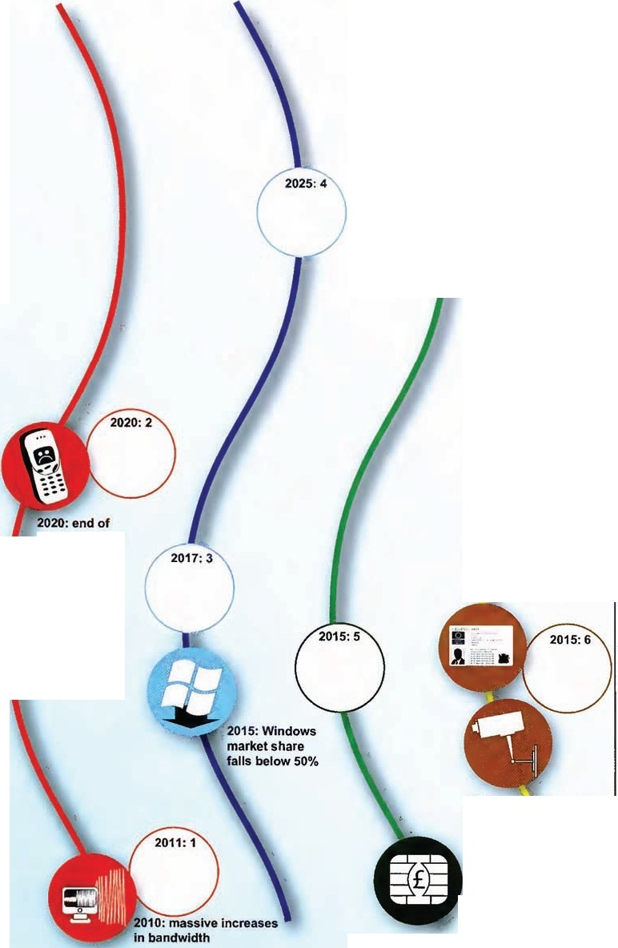2030

0 - 2020

mobile phones

2016: most countries
.:have ID cards

2014:surveillance In most neighbourhoods
"

2011: paper money replaced bysmart media

2010

12 I UNIT 1 Convergence in Telecoms and IT

18 Discuss these questions or write down short answers.
1 Have any of these predictions already come true?
2 Are there any predictions that will come true sooner than the extract suggests?
- Are there any ofthese predictions that you thinkwillnot come true?
- What other predictions would you make about the future of hardware, software, telecoms, or lT?
.. .
DEGREES OF PROBABI LITY IN THE FUTURE

We can use different expressions to talk about how surewe are that somethingwill happen in the future.

100% | will definitely | is/are sure to, is/are bound to,is/are certain to
75 % | will probably | is/are likely to, there's ogood chance that
50 % | will possibly | may, might, could
25% | probably won't | is/are unlikely to
0% | definitely won't | there's no chance that

19 Re-write these sentences usingthe word in brackets.See the example.
A lot of companies are likely to go out of business. (probably)
A lot of companies willprobably go out of business.
1 Windows is unlikely to remain the dominant force in software. (probably)

2 People could stop using cash by around 2015. (may)

- The mouse willdefinitely disappear in the next few years. (bound)

- There's a very good chance that mobile phones wilt be replaced with something different. (probably)

s There is no chance that the rate of change will slow down. (definitely)

20 Work with a partner.You each have some predictions about two more areas of technology. Use the expressions from the language box above to show how sure you are about your predictions. Mark the predictions onto the black timeline on page 11.

UNIT l Convergencein Telecoms andlT I 13

Read the newsfeeds about Telecoms andIT and answer the questions below.

Nokia laptops? One billion downloads innine months
In another example of convergence, Nokia is Apple announced that 13-year-old Conor

considering a move into the PC market. Unlike
netbook and notebook specialists Acer, who unveiled a new smart phone at the Mobile World Congress,Nokia is goinginthe other direction.

Lower and lower
India has announced plans to produce an educational laptop, the 'Sakshat', which will allow millions of schoolchildren to have access to the internet. The machinewill sellforjust $20, butwill come withwireless connectivity and 2GB of RAM.
Mulcahey downloaded the billionth app from
the iTunes store. Apps use the technology of the iPhone like the Multi-Touch interface, the accelerometer, GPS, real-time 3D graphics, and 3D positional audio. Most other operators and manufacturers are trying to enter this popular market.

Adobe Flash on TV
Adobe has secured a deal to put Flash software onto the chips most commonly used inside 1V sets and set top boxes. The move should

facilitate the creation of web-based content

Clouds ahead
Ina new move intothe worldof cloud computing, Google has announced plans for the Google drive or Gdrive. Instead of storing information on PCs or laptops, users will be able to store data and applications on Google servers and access them over the internet.

Is Skype now the biggest Telecoms company in the world?
According to TeleGeography, Skype handled 33 billion cross border minutes in 2008, up 41%, against an industry increase of just 12%.Skype
on 1V screens. The move further develops the increasing convergence of 1Vand PC/internet in the home with users likely to use their TVs for internet searches and increasing consumptionof online media content.

Alcatel-Lucent posts eighth loss ina row Alcate l-Lucent,the world's third largest te ecom equipment manufacturer , reported its eighth straight quarterly loss. The €3.89bn loss was said to reflect the drastic deterioration of the global outlook and the change in strategy.

now accounts for 8% of the international voice. A
Other VoIP providers make up a further 23% of .,.

the internation-al m-arket.
"""':""-=,,...--, ------ -----

Accordingto the newsfeeds:
1 Where are Nokia and Acer already competing?
2 How much willthe Sakshat cost?
- How will users access the Gdrive?
- What is the total VoIP market share for international voice?
- How longhas it taken Apple to generate one billion downloads?
- For how many months in a row has Alcatel-Lucent made a loss?

OVER TO YOU

- Do you know of any developments to the stories in the news feeds?
- What are the latest examples of technology companies convergingthat you have noticed?
- What sorts ofcompanies do you think will be the bigwinners and losers in a converged future?

14 I

Mobility

il?t"l'
How mobile are you? Complete the questionnaire and then compare with a partner.

When you are on the move, how often do you:

speak to family?
speak to work colleagues? speak to customers?
buy something?
check your bank account? listen to music?
send emails?
write presentations? build spreadsheets?
access an information database? download and usea new application? use Location-Based Services?
Never Sometimes Often

AUDIO

8
Discuss what device you use for these activities.
1it.1:m1 .J\!JIUi
1 Listen to the conversation between Antonia Gomez, who runs a smallfood export company, and Kate, a sales assistant Ina branch ofTopTech, a chain of technology shops. She is explaining what communications technologyshe needs and Kate is giving her advice.

Match the sentence halves to complete what Antonia says she needs to do.

1 it's not very convenient
2 it's a bit embarrassing
3 Iwant
4 Isend and receive
5 Ineed to
6 I'd like to
a charging my phone in a customer's office b be able to do all these things onthe move c emails all the time
- be able to read the attachments
- the basic functionality of my current phone
- only beingable to access all my information when I'm in the office

UNIT 2 Mobility I15
1 Microsoft Internet EXplorer
M!fiiilM

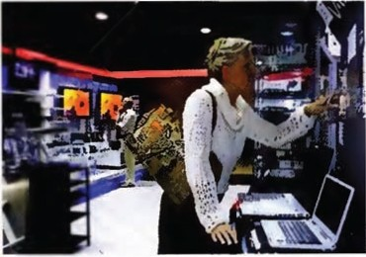TECH TUTORIAL

Bluetooth
A technology that allows short-range, wireless connection between devices
LBS= Location-Based Services
Information, products, or services provided to you based on thelocation ofyour device (using GPS or the mobile network)
GPRS -= General Packet Radio Service
Provides packet-based connections on mobile networks GPS = Global Positioning System
Allows receiver toidentify its position anywhere on earth

2 Listen againand comp ete the two tables of features for the SuperMob360 and the Silver Lite A2.
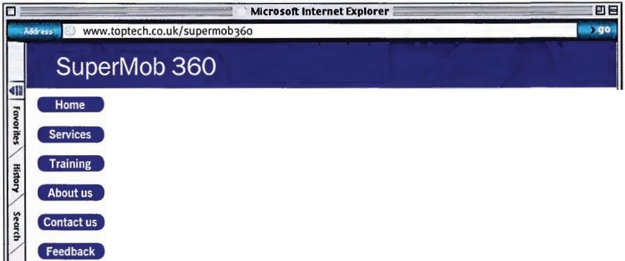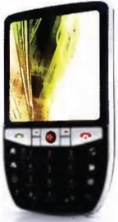Tick (.I) the features that Kate mentions.
M!fi1if¥

GSM
GPRS
GPS
FM radio
Camera
Email
Internet
Data transfer 1GB/month
Data transfer 2GB/month
Battery life 4hrs
Battery life 8hrs

External mouse
Full keyboard
Core 2 processor
Wireless broadband
Wi-Fi
Bluetooth
Screen size 14""
Screen size 16""
Weight 3.5kg
Weight 2.5kg

16 I UNIT 2 Mobility

3 Work with a partner. One of you isa salesassistant and the other isa customer.Look at the language

box below and role play the situation.
lilJ;OllJ;Ul!f
- Partner A file 2.p.75
Putner 8 file 2. p.n

EXPRESSING NEEDS AND RECOMMENDI NG

Needs
Iwant...
Ineed to... I'd like to...
It's not very convenient only... It'simportant for me to...
Recommending
What I'd recommend Is . I'd go for ...
It would be worth getting•.. You should get ...
You could try...

4 Imagine you areAntonia Gomez.You want to buy the SuperMob 360 but it isn't in stock and the sales assistant needs to go to the warehouse to check she has the Silver Lite A2.Wbt would you do?
1 Walk out of the shop and buy the same products online (they will probably becheaper).
2 Wait to see ifthey have the laptop.
3 Tell the sales assistant to call you once she has the products you want.

MOBILE TECHNOLOGY IN RETAIL

AUOtO
5
9
Antonia Gomez walked out of the shop and bought the products online.This is not the first customer TopTech haslost due to similar problems.Listen to the message Bob Murray,the store manager,left Malcolm Frith, TopTech's IT Director. Complete the table below with his complaints.

Supply chain
Warehousing Tills Customer service

Can't see what's going out and what's coming in
6 Complete the email that Malcolm sent Bob with thewords in the box.
terminals • schedules • chain • trends • converged • continuous • stock • renewal

Dear Bob
I'm sorry to hear about the business issues you are experiencing dueto our ITinfrastructu re.There has been a lot of activity in the background and we are on the verge of a major IT 1 programme that will address your concerns.Please readthe attachment to this emailwhichdetails what the newsystem will do.
Basically the new system will giveyoucomplete supply 2 visibility,guaranteed
3 replenishment of stock, electronictagging,electronic point-of-sale _
and 5 fixed-to-mobile phones.
As well as the systems outlined inthe attachment we willallreceive better management of information from the newsystems. Store Managers will receive a number of automatic reports at 0900 every day,detailing the previous day's trading, 6 levels, delivery 7, and buying
R

Ihope this helpsaddress some of your concerns.Please feel free to contact meto discuss the rollout schedule for your particular store.
Regards,Malcolm

UNIT 2 Mobility I 17

7 Read the attachment.

Supply Chain
Single, fully integrated Supply Chain Management solution to be implemented. This will:
- give visibility across the supply chain from store/warehouse to distribution centre.
- give information on what suppliers are manufacturing and when products will be available.
- host new servers and applications at TopTech data centre with rollout of new IP network to all stores & suppliers.
- display stock levels in real time so when an item is purchased a replacement order is automatically placed with suppliers to replenish stock.
- automatically schedule a delivery when stocks reduce to a certain point, to ensure new stock arrives at store before inventory depletes.
Warehousing
RFID solution to be implemented. This will:
- tag allgoods to make them identifiable at all times throughout supply chain.
- allow sensors in loadingbay and warehouse to monitor deliveries, locate items in warehouse, and track purchases.
- reduce shrinkage through increased monitoring.

8 Find words in the attachment that mean:
Tills
Legacy equipment to be replaced with EPOS touch screen terminals.These:
- can be positioned anywhere in store and connect via wireless LAN.
- have software to allow staff to check stock levels and give customers up-to­ date information allowingstaff to suggest alternative products if others not in stock.
- include two wireless Waiter Pads per store which staff can use as mobile tills as they attend customers anywhere in store.
- use latest chip and pintechnology for increased security.
- will be integrated into supply chc;in and data centre with new pricing and campaign information uploaded daily.
Customer Service
- single number for customers to call with calls handled at a centralized call centre to keep store staff free to deal with customers.
- all staff to be issued with a cordless phone to receive any calls that do have to come throughto the shop floor. These phones are converged fixed-to-mobile phones which
operate as telephone extensions in store but operate off-site as mobile phones without call interruption.

1 are making | 5 | runs out
2 installing new systems | 6 | loss of stock
3 show | 7 | old and out of date
4 bought | 8 | not in the company's buildings
TECH TUTORIAL

EPOS = Electronic Point Of Sale
A networked and programmable electronic till
RFID = Radio Frequency IDentification
A system of tags and readers that communicate information via radio frequency
LAN =Local Area Network
A computer network coveringa local area, such as a home or an office

18 I UNIT 2 Mobility

9 Complete the email that Bob sent to his staff about the newsystems.Useyour notes from exercises and the details in Malcolm's emailattachment to explain,insimple terms. what the new system willmeanfor the staff.

__J

Hi all,
Iknow that you have all been frustrated by the problems we have with our technology. Ihave been in contact with our IT director and he has told me that they are implementing a new system which should make everything better. The fully integrated Supply Chain Management solution will mean that we will be able to see exactly what's coming and going...

10 Use the clues to complete this puzzle and find the hidden word related to stock planning.
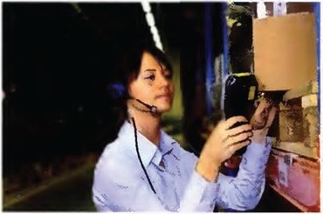1 An acronym for a system of tagging products
2 A document that accompanies an email
- A Blackberry is a type of hand-held ...
- A n acronym for a type of electronic till
s Laptops can be Wi-fi- ...
- A technology that allows short-range, wireless technology
- To put somethingon to a system such as the internet
- A place to store goods
- The process of gettinggoods from manufacturers to shops (two words: 6, 5)

1
2
I I
I I I
3
4
5
6
7
8
9
I
I
I
I

UNIT2 Mobility I19

LOCATION· BASED SERVICES
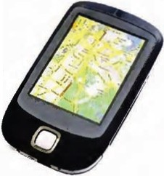11 Match the words with thedefinitions.

1 Mapping
2 Tracking
3 Navigation
- finding the best route from one point to another.
- following the progress of a movingvehicle or person c creatingan image or diagram of an area

When do you or your company use a mobile device to help with each of these?
Can you think of any uses that other organizations (e.g. police, insurance companies) have for these technologies?

AUDIO

10

12 Antonia Gomez isthinkingof opening a retailoutlet for herfood products and is interested in understandinghowto apply location-based services to attract customers to her outlet. She attends a seminar onthe subject at a retailand mobility conference to find out more.

Listen to the seminar and match the words with the meanings.

- geomarketing a gives personal information to (a service)
- subscribes to (a service) b time taken to travel from a satellite and back
3 inputs to (a service) c advertisingto people dependingonwhere they are
- mash up d pays a regular amount for (a service)
- transit time e an electronic signalsent by a satellite to a mobile device
6 timing signal f combine different types of information from different sources

13 listento the extract again. Say if the following statements are TRUE (T) or FALSE (F).

1 | Most smart phones can use GPS technology. | D
2 | Antonia could alert peoplewith mobiles that they are near her shop. | D
3 | Geomarketingcan give consumers usefullocal information. | D
4 | Antonia is planning to open a chain of pizza restaurants. | D
s | A user's location can be calcu lated to the nearest 60 metres. | D
6 | Antonia thinks the system would be suitable for her business. | D
14 Inyour opinion, what are:
1 the two biggest advantages to a business of using location-based services?
2 the two biggest advantages to a consumer of using location-based services?
- the two biggest disadvantages to a business of using location-based services?
- the two biggest disadvantages to a consumer of using location-based services?

Compare your opinions with a partner.

20 I UNIT 2 Mobility

Read the article and answer the questions.
RetailWeek
Latest retail news, jobs,analysis and market data

Cash,card or mobile phone?
Right now, retailers need to get to grips with the dawn of contactless payment
In the past week there has been a raft of announcements and news on alternative payment methods. Technologists everywhere are stillconvincedthattheycancome upwithsomethingbetter than cash for smaller transactions.
The alternative method that retailers mustconsider inthe immediate future is contactless payment. A few stores in London have gone live with the Barclaycard Business contactless payment system already, more than 1,000 other sites have signed up to use it, and 3,000 consumers have registered their interest inthe system's OnePulse contactless card.
A recent YouGov survey commissioned by an ATM operator highlighted that consumers have fraud concerns about contactless payment. Yet similar surveys of online shopping also tend to highlight si ificant fraud fears, whilethe number ofpeopleandvolume of theironline transactions continues to f!JOw.
In the longer term, the techies are still betting on the mobile phone becoming the new wallet PayPal has gone live with a mobile payment system already. Others are still very much a work in progress; such as the mobile payment system dubbed GPay that it has emerged Google has filed a patent for.
Another, PayForlt, is a mobile paymentscheme for transactions under £10that allfive major mobile network operators have signed upto. At present, it is only really beingused to payfor m::>bile phone content. However, the plan is to expand this so consumers can make payments to onl ne retailers when they access their sites via mobile phone.
If this seems far-fetched, just take a look at some of the retailers that have registered for .mobi internet domains - a type of web site address that highlights the fact that the site has been optimised for viewingon a mobi e device.
It is good practice to buy any domainthat may pertain to your brand.However,it is interesting to note that innovative retailers such as Amazon and Tesco have already secured domains that will allow them to launch mobile-optimised sites, should they wish.

Say if these statements are TRUE (T) or FALSE (F).

1 The Barclaycard Business contactless payment system is already being
 | used in London. | D
2 | Contactless payment systems carry a greater fraud risk than online shopping. | D
3 | It seems likely that mobiles willbe increasingly used for making payments. | 0
4 | Major retailers are worried about the competition from mobile-optimised sites. | D

- Do you know of any other systems ofcontactless payment?
- Do you think we willever stop using cash? If so, when?
- Doyou think that contactless payment and other electronic forms of payments are more open to fraud thantraditional forms of payment?
- Do you know of any retailers that have registered for .mobi internet domains?

I 21

Software

Think about your answers to thisquiz.
Your favourite and least favourite piece ofsoftware.
I love-------------beuiuse ------
'hate buause -----
A piece of software you use regularly andwhat its mainadvantages and disadvantag s are.

------------ | -i5 9reat because _
------------ | -is not so 9reat because ---- | -
The best cheap I freeware application youhave downloaded from the internet.
I lov -------------betau:Je ------
Now discuss your answers with a partner.

THE SOFTWARE DEVELOPMENT PROCESS
1 Complete the diagram with Information about your company•s IT.

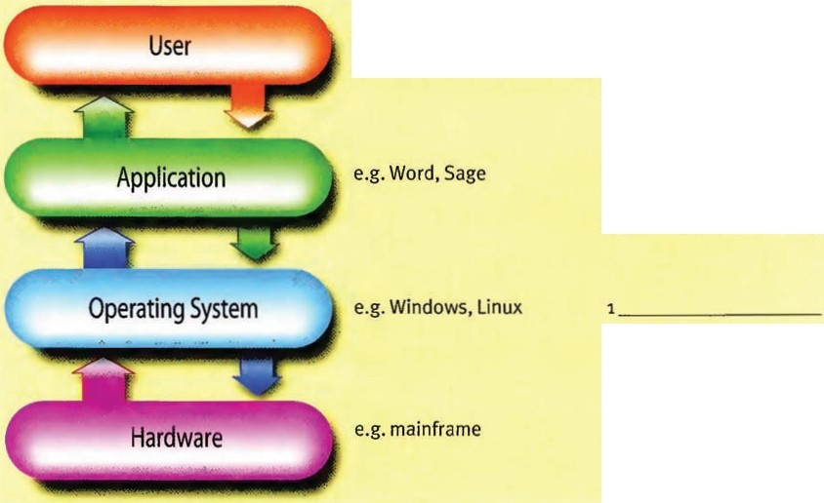
e.g.different departments: 1 _ _
Finance, HR, etc. 2 __
3 _ _
1 _-"o---
2 _
3 _
1_ ;;;=-..;,;;;.;_--- _
2 _
3 _ __

What problems might your company have if it took over another company that used different operating system sand applications?

22 I UNIT 3 Software

2 Cleverbox is a manufacturer of a new type of IProuter that is bought by telecoms network operators.It hasgrown rapidly. both organically and through acquisition.This rapid growth is now causing business problems with integration.The Cleverbox IT Director, Jane Simmons, sent an email to Elizabeth Hardy. from software development company Talking Software Ltd,
outlining their problems.

Complete Jane's email with the expressions below.

applications • customized • data format • helpdesk • operating system • releases • software licences • upgrade

Cleverbox uses a single operating systemacross its departments, but many of our departnents have
______,their applications and processes,which means that there are
2

------· ----
and integration problems inthe company. Ontop of this,

some departments have been slow to 3, which means that different departments have different software 4• Things are gettingvery expensive because all of the

------
-· -----swe have to buy. Maintaining all of this and providing

____ 6 servicesfor our customers also costs usa lot of money.
To make things even more complicated, our latest acquisition, Smart Route, uses acompl3tely different
____,_ __ 7,which means that none of their 8 will work with Cleverbox.

A
...

:---- -- "=" -- M
3 You are goingto hear Elizabeth giving Jane a short sales presentation about Talking Software . Before you listen, check that you know the meanings of these words. Match the words 1-s2 with the definitions a-l.

1 | bespoke | a | small and medium-sized enterprises
2 | bugs | b | specially produced for someone
3 | cutover | c | detailed description of what is required
4 | modular | d | work finished or completed
5 | off the shelf | e | strong, reliable
6 | output | f | standard and commercially available (package)
7 | robust | g | in separate, independent sections
8 | rollout | h | errors in a program
9 | sign off |  | gradual implementation
10 | SME | j | final move to a new system
11 | specification | k | finish and leave
12 | steady state | I | working properly and reliably

UNIT 3 Software I 23

AUOIO
® 4
11

Listen to Elizabeth's presentation and complete the three slides detailing Talking Software's areas of expertise.

Team
20 _ 4 • programmers and coders
Business Processes
-
- ---
-
Team
1Consultants

Tasks
_ 1 business processes and provide a
_ ___3 or Software Requirements Analysis.

Tasks
Design __ and code and compile software Test for 6
_ 7 existing software products

ApplicationImplementation

Ten people led by a _ _11

Tasks
Install _9 software Install customized products
Install 10 packages
5 Discuss these questions with a partner.

1 What problems have you personally had with software packages?
2 What problems has your company or organization had with software applications?
- What problems have you seen other people or other organizations have with their software?
- How were these problems fixed in each scenario?

24 I UNIT 3 Software

SOFTWARE SOLUTIONS
6 After analysingthe two businesses, TalkingSoftware produced a report for Cleverbox. Readthe Executive Summary below and match sentences 1-6 with sections 1)-iv)c of thesummary.

1 The accounts packages are not being used effectively.
2 Information needs to be stored in one location and this will save money.
- The software needs standardizingand updating regularly, and this will save money.
- The personnel departments of the two companies operate differently.
- One of the bespoke applications is not particularly useful and cannot be used by the other company.
- The two companies need to use a single operating system.

Cleverbox Software:Problems & Options

Executive Summary
Talking Software carried out an analysis on the IT estates of the two businesses and the high level summary is as follows:
Problems: Talking Software has notedthat:
  - The IT Infrastructure of the two businesses requires consolidation into a single data centre and database .There is an opportunity to reduce cost through server consolidation. Communications infrastructure is compatible (MPLS based) but will requiresome capacity
increases on certain links to ensure the end users' experience of using the applications is acceptable.
  - Server Operating Systems are incompatible being Windows and Linux. Desktop Operating Systems are also a problem because Windows and Mac OS are used.
  - Software Licences: all departments have been purchasing their own licences and there are lots of agreements with lots of vendors and novolume discounts. There are no coordinated upgrades leaving some
users and departments without the software functionality they need. This is all leading to high numbers of calls to the IT Helpdesk and significant training costs.
  - At a departmentallevel there are the following issues:
    - Human Resources: Cleverbox uses HR Pro as its HR application in real time,whilst Smart Route runs their HR activities using Microsoft Excel updated monthly.
    - Finance: Cleverbox Finance is struggling to integrate with your own HR, Sales and Procurement applications due to

different data formats and scheduling. This is leadingto dela'S in Payroll for your own staff, late billingto your clients and
late invoice payments to suppliers. Smart Route usesthe Sage Release 2.0 which you will not be able to integrate to.
    - Manufacturing:Cleverbox uses a self developed applicatior that integrates well withinthe business but will be completely incompatible with Smart Route.Although it is integrated,the functionality is limiteci and it provides very little management information.
Options: Given the observations above we believe the options for Clever:>ox management are to:
Invest in Smart Route to change their operating system and replace their applications to mirror Cleverbox. A second stage would then consolidate the
information of both businesses into a single database. This solution willsupport your
business for the next three years. The cost of Option 1 will be one year's profit and itwill take two years to execute.
2 Scrap all the legacy software in both businesses and invest in an off-the-shelf ERP (Enterprise Resource Planning) system. This will provide a common database and synchronized data across the combined
business. Modular software applications for each department allow every department to store and retrieve standardized data in
real-time. This option is future proof. Option 2 willcost two years of profit and take one year to implement and wilIsupport your business for seven years.

UNIT 3 Software I 25

- Read sections i) to iv) again. Find words or phrases that mean:

1 | joiningtogether into one | 6 | price reductions for buyingin bulk
2 | able to function well together | 7 | properly organized
3 | improvements in size or power | 8 | usefulness
4 | unable to function well together | 9 | problems
5 | sellers | 10 | combine to work together
- Usesome of thewords from exercise 7to complete sentences 1-5.
1 The trial version only has limited -ifyou want to useallthe features, you have to buy the fuIIversion.
  - We had some serious _ with our IT infrastructure, so we called in some consu ltants.
  - If the printer isn't with your operatingsystem, itwon't work.
  - After a series of ,our broadband speed has now risen to 24Mbs
s The rollout of the new software was very well ,and everythingwent smoothly.
6 Ifall our departments buy new software licences at the same time, we'll get good _ _

- Look at the two options in the summary. Put these notes on each option into the correct columns.

will last for seven years can be done in two stages
only requires one company to change itssoftware willlast for three years
can be implemented ina year
can be implemented over two years willcost two years' profit
willonly cost half of the other option

Option 1:features and advantages Option 2: features and advantage;

Can you add any other features or advantages to the list?

FUTURE CONSEQUENCES

We often use the first conditional to talk about the future consequences ofpresent actions.
If they choose option 1, it will cost two years 'profit.
We can also use this structure to talkabout future ability and obligations. Future ability: will beable to, won'tbe able to
If Smart Route changes its OS, both businesses will be able ta use a single database.
Future oblfgation: will hove to, won't hove to
If theychoose option 2, they will hove topay more up front.

10 The recommendation section atthe end of the Executive Summary is missing. ook at allthe information inthe text and discuss with a partner which option you would recommend.

Now write a short paragraph summarizingyour recommendation.

26 I UNIT 3 Software

PROJECT MANAGEMENT

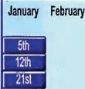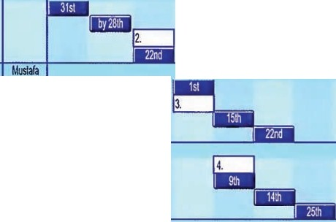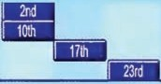
Cleve/box ERP Rollout Project Plan
Commercials & Governance Negotiate & SignContract Identify Stakeholders
Project Kickoff Pro·ct Handover ITInfrastructure
MPLS Bandwidth Increase Datacentre Rudy
·All Departments
·Identifying Datato be Migrated Construct Data Template inSoftware Configuration
Customization
Finance Data Freeze
Migration
Test Cutover
Human Resources Data freeie Migration
Test
Cutover
Procuremellt
.Data Freeze
Migration Test CUtover
Manufacturing
•Data Freeze
Migration
Lead
Eizabelh
April May June July
ust September October
5.
Jane
1.
Pedro
Chuck

Sandra

Xu
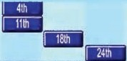Test
Cutover

11 Elizabeth from Talking Software is having a conference call to discuss the rollout of the new ERP software for Cleverbox.Look at thechart and answer the questions.

1 When willthe project kick off?
2 Who is responsible for the Finance department?
- What department does Chuck lead?
- Who is in charge of upgrading the MPLS?
s When will the data freeze start for the Finance department?
- Which department willbe migratingdata on May 9th?
- When will HR start testing?
- When will Manufacturing cutover?

AUOI O

12

12 Listen to the extract and complete the missing dates 1-5on the chart.

UNIT 3 Software I 27

- Listento the extract again.Sayif the followingstatementsare TRUE (T) or FALSE (F).
1 Elizabeth is expectingsome delays and missed deadlines. D
2 Elizabeth explains the workstreams involved in preparingthe data templates. D
- Thefour departments will all follow a similar procedure for the ERP rollout. D
- Mustafa is unsure when the data migration willbegin. D
s HR cannot employ anyone new after May 3•d. D
6 Manufacturingwillbe very busy duringthe testing period. D
- Match the words 1-8with the definitions a-h.

1 | bottleneck | a | delay
2 | within scope/out of scope | b | leave unchanged
3 | slippage | c | blockage
4  s | rollout  stick to (a date) | d  e | finaldate for completing (a project) move (data) from one system to another
6 | dirty data | f | implement and start using (new software)
7 | deadline | g | information with mistakes (e.g. spelling mistakes)
8 | migrate | h | suitable/unsuitable for inclusion

- Complete this extract from anemailusingsome of the words above.

I'msorry to have to tell you that there has been some ____ ,in the project andwe Non't

be able to | 2our original | 3 on July 30"' for completingthe
------ | 'of the new software.
Pedro's absence for three weeks caused a bit of a _ ___5, andthere were more delays when we realised that there was still some 6 inthe database that needed cleaning up.
Still,Iam confident thatwe can complete the project by the end of next month.

TIME PERIODS

Prepositions and time words
Look at the prepositions we normally use with these time expressions.
at 6.15 on Monday the end of the month the 15th
the weekend August 11th

in August
2007
the199os

by and until
by means not later than.
Ineed that report by Wednesday. (Monday,Tuesday or Wednesday willbe OK. Thursday willbe toolate.)
no preposition yesterday
last week next week tomorrow
until means from timeA (often now) to time B We will be working withyou until theproject is completed.
'Y'e will be workinghere from now up to the end of the project.)

28 I UNIT 3 Software

16 Complete the sentences with by, until, in, on, at, or - (no preposition).
- Would you mind waiting Mrs Langton gets back?
- By the way, could Iremindeveryone that our next meetingwill be Tuesday 181
h
11.10.
- Ihad a few problems connectingto the internet Iinstalled Wi-Fi.
- Could you give this invoice to Helen? Ithink she's comingin _ tomorrow.
s My father worked for NCR until he retired 1990.
- We can't usethe new system it has been fully tested.
- Ineed that report 6.30 tomorrow at the latest.
- What did you do the weekend? Did you go to London?

17 Listen to Pedro's description of the process. Complete the extracts with the missingwords.
1 ----------------- we need to iden:ify allthe data that you each have to migrate ...
2 each department will then construct a data template ...
- ...this needs to be done ------the end of next month.
- ------------•the database will be configured ...
5 __,any customization of your templates or processes must be completed ...

18 Read the situations below and choose one.Think about five steps for each situation. Usesome of the sequencing words above to explain your situation briefly to a partner or write a short
paragraph puttingthe steps insequence.

- A non-expert wants to format the hard drive on his PC and re-load the operat ingsystem, but doesn't want to lose any important files or emails. Explainthe steps in this procedure.
- A company is movingto new premises in the same city. Explainwhat steps they need to take to make sure that their IT system can move with the minimum amount of disruption.
3 The Finance Department of a small company has decided to start usinga new accounts package. Explainwhat steps it needs to take to use the software effectively.

19 Work with a partner to complete the work streams ina software rollout programme.

UNIT 3 Software I 29

Read the article about cloud computing and answer the questions below.
Who is in the cloud1

he "cloud" and cloud­ computing are amongthe
T
buzz words of the year.The big players are moving into this area in a bigway. Google
willalready runyour emailand host your documents, and
its App Engine lets users run custom applications. Amazon has a service that allows users to set up virtual servers on the internet, and Microsoft is
joining the party with Windows Azure.
At the same time, the concept of cloud computing is far from new, and one company
that has been in the business I since 1999 (an age ininternet terms) is salesforce.com. The business lets customers manage their sales data, leads and other
information on the internet using salesforce.com's online applications, and with over
$I bn inannual revenue. it is clearly a model that works. Marc Benioff, the company's

44-year-old chief executive and co-founder is convinced that cloud computing is the way ahead.'This is the future,' he says. 'lfit isn't, I don't
know what is. We're init. You'regoingto see this model dominate our industry.'
Benioff sees the service cloud as the alternative to call centres and telephone helplines. He believes that when customers have a problem with a product or service they no longer calla helpline, they go to Google.
Companies like Orange are already usingthe service cloud, where they can set up their own web portal with links to customer services and other applications.
Butare there any dangers to this the brave new world?
When Gmailwas hit by an outage in February,Twitter was alive with cries about the risks of moving mission-critical data

and applications outside your own IT department's control, even though the downtime lasted only about two and a half hours. Besides questions about reliability, some doubters also voice worries about privacy
and security.
But supporters of the cloud say that organizations like Salesforce and Google do a much better job of uptime and transparency than most ITdepartments. 'All complex systems have plamed and unplanned downtime,' says Benioff, who claims 99.9% uptime last year. The reality
is we are able to provide higher levels of reiability and availability than most
companies could provide on their own.'
His 55,000 customers and
million subscrbers, will be hoping that heis right.

•

Say if the following statements are TRUE (T) or FALSE (F).
1 Salesforce has been operatingcloud services longer than the big players. D
2 Salesforce has had to change its business model because of falling profits. 0
- Benioff believes cloud computing will replace call centres and helplines. D
- Cloud computingsuffers from more unplanned downtime than average in-house 0
IT departments.

OVER TO YOU

    - What applications do you regularly use that are provided in a "cloud"?
    - Do you think people willbe comfortable with all software being provided remotely inthe future?
    - What are your reasons for your answer?
    - How many clouds will there be? Doyou think one big service provider could provide a single cloud for everyone?

ao I

Networking

Look at the map.What doyou think the red lines represent? What do you think the blue shadows represent? Discussyour answerswith a partner.
STARTER

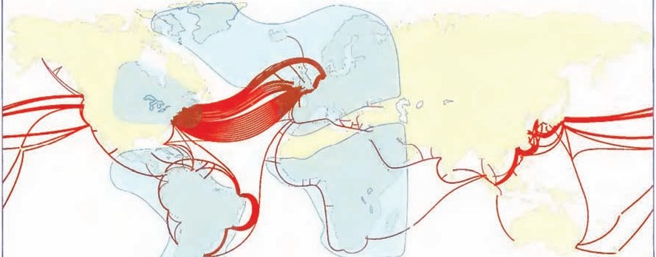

GLOBAL INFRASTRUCTURE
1 You will hear a call between Dave Wells,the telecoms manager of an oil company in London and Jerry Rigg, a geophysicist in charge of a small exploration team in West Af rica .They are
discussing the infrastructure that isavailable and how they will set up a local exploration office and communicate regularly with London.
These abbreviations appear in the extract you are about to hear.Think about how they are pronounced .Which one isthe odd one out?
PTT MPLS PSTN VSAT DSL
TECH TUTORIAL

DSL = Digital Subscriber Line PTT = Public Telephone & Telegraph Digital lines that are provided by telephone A country's telephone network operator companies VoIP= Voice over IP
PBX = Private Branch Exchange Packetized voice over Internet
A telephone system bought and used by a company VSAT =Very Small Aperture Terminal
intheir office A small satellite dish normally mounted on PSTN = Public Switched Telephone Network the roof of a building
A country's telephone network

UNIT 4 Networking I31

AUOIO

13

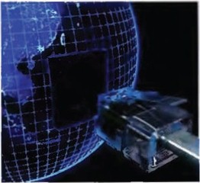2 listen to theextract and look atthe diagrams. Tick {.I) the infrastructure that has been completed and Is available. Cross (.X) the infrastructure that is still being developed or is being planned .

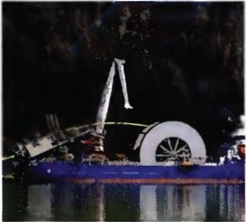

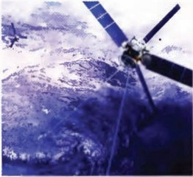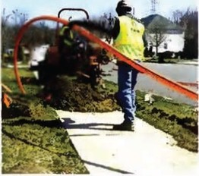1Submarine cable to Europe LJ 2 Intelsat connection D
3 Global Ethernet services [l

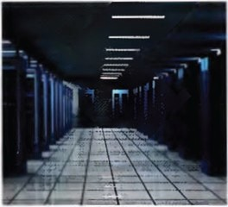

4 National fibre backbone D
s Digital switching equipment 06 Fibre local loop D

J Listen to the extract again. Complete this email with the words in the box.
infrastructure • capacity • localloop • redundant • data network • teledensity
- lead times • global Ethernet

Hi,
I've had a talk with Jerry about the telecoms that is available out there andit's still pretty basic. On the plus side, there's a high 'fibre cable down the west coast and the country is connected via Intelsat 1, so there are _ __ connections, so basic emails and phone callswillnever be a problem even if one of them goes down.
However,at the moment there are nointernational _ _ __
providers out there so ------ _ _s services are not available. They will be able to get a fixed line, but the 6 is just copper
I

below average.

and
_ 7 are very long because _
___8 is well

Best, Dave

32 I UNIT 4 Networking

4 From your knowledge of telecoms note three thingsthat Jerry can easily do and three things Jerry can't easily do with the existing infrastructure.

When you have finished compare your noteswith your partner.

5 Match the two part verbs in Column A with the meanings in Column B.

A |  | B
1 | put in | a | consider, think about
2 | phasing ...out | b | discovered
3 | dug up | c | get information about
4 | rolling out | d | finishingwith
5 | look at | e | happening
6 | goingon | f | implementing
7 | figure out | g | install
8 | found out | h | taken out of the ground

6 Complete the sentences with the two partverbs from exercise 5.
1 We've been travelling around tryingto _ what telecoms infrastructure is available.
2 What we have ------------is that West Africa iscon1ected to Europe
- Some ofthe international data network providers are starting to __ _
expanding their networks
- To its credit, the PTT is a nationalfibre backbone.
s They are the old electro-mechanical exchanges.
- Digital switchingequipment is being the new exchanges.
- So there's a lot at a national level.
- The problem with the copper pairs in the ground is that they get _

Listen to the extract againand check your answers.

UNIT 4 Networking I 33

7 Read this emailfrom Mgumba to David Wellsgiving some information about the country's main telephone network.Complete the email with the words in the box.

PSTN • digital • twisted copper pair • VoIP • electro-mechanical fibre • PIT • regional • PBXs • local

1 To: Dave Wells From: Mgumba Batswana Subject: The PSTN & Voice Services,In Country
Dave
I've done some digging for you. The
' was of course based on analogue
technologies. Most of the equipment in the old exchanges was 2 but this
started being phased out five years ago. Digitalequipment was installed in all the _
_3 exchanges first and now 100% of intercity traffic is digital. Dialling codes exist for each city. There are still some 4 exchanges that are analogue but these are switching over to 5 at about one per month. The local loop/last mile is predominately
__6 but fibre is available for large offices in city centres. Lead times are
a minimum of 30 days for copper and 90 days for
__ _a does install and maintain digital
7, if available. The
9
for businesses.
Their range can grow to about 500 extensions and two switchboards. I have only noticed
one provider talking about
Mgumba
!:;:- --
10 services.
"'
"'
a

8 Make notes onthe most important changes in the last few years that have affected:
- your country's PSTN (Public Switched Telephone Network).Think about:
  - equipment in local and regional exchanges.
  - 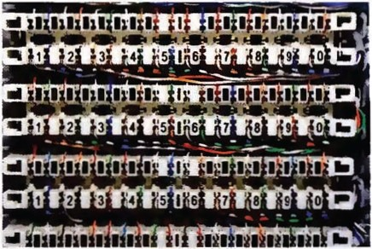the rollout of fibre.
  - broadband speeds.

- your own use ofvoice calls. Think about:
  - your use of landlines.
  - the priceof calls.
  - your use of mobile technology.
  - your use of VoIP.

Compare your noteswith your partner.

34 I UNIT 4 Networking

ENTERPRISE NETWORKI NG
9 Readthis article from Big Oil's internal magazine about their experience in West Africa .As you read, number the order in which these thingshappened.

a The company set up a 100Mb Ethernet LAN. b The team were given satellite phones. c A contractor fitted out the office with CAT5 cabling.___
d The company installed a private fibre loopto the new MPLS node. e The company installed VoIPand teleconferencing applications.
f A global data networking provider extended WAN services to the capital.

hen Big Oilstarted its search for oil in West Africa. their geophysicists
W
carried out surveys to see whether there were any oil reservoirs underground. These surveys produced a lot of data which needed to be sent back to Head Office, but how do you transfer half a gigabyte of data out of the jungle when the local telecoms infrastructure isn't up to it, or not there at all? We talk to Dave Wells, Telecommunicati ons Manager at Big Oil, about these challenges.
'The geophysicists who went out there first usedsat-phones totransmitvoice and data. But of course once the decision to drillwas made, we had far more users to support withvarious requirements in a proper office environment.'
Big Oil's telecoms team is used to providing global voice and data connectivity into remote locations, says Dave.'We worked with one of the global data networking providers to extend their WAN services here and convinced them to put an MPLS node
into the capital. This meant they had a local presence and it allowed us to connect to their global network. We then had 8Mb

connectivity from the router in my comms room in London down to the capital. We decided to pay to dig a tre'lch and lay our own fibre local loop to give us reliable, high capacity bandwidth to our new premises.'
'A localcontractor wired out the officewith CATS cabling. We installed and remotely manage our own LAN hub and run a 100Mb Ethernet LAN arou1d the building to laptops and PCs which have the same specifications and applicatbns as London. We decided against a standalone PBX because we had a full 8Mb for voice, data andvideotraffic. Weset upour 30staff with VoIP and teleconferencing 3pplications on their computers and they use headsets for their voice calls. This all works well, and from the traffic analysis we can see that they actually videoconference with London more often than just talk because of the infrastructure we put in for them.'
Despite being remote, the team on the ground now have the same capabilities as London, another example of how telecoms and ITcan support businesses that operate in hard-to- reach places.

UNIT 4 Networking I35

- Read the text again. Say ifthe followingstatements are TRUE (T) or FALSE (F) according to the text.
1 | The geophysicists did not find evidence of underground oil reservoirs. | 0
2 | Dave Wells said the new office only needed satellite phones. | D
3 | A global networking provider opened a new facility in the capital. | D
4 | The exploration office installed its own localloop. | 0
s 6 | The LAN in the exploration office is managed from London.  The staff in the exploration office make alltheir callsvia their computers. | D  D

- Readthe text and find a word or phrasethat means:
1 A person who is in charge of a company's telecommunications.
2 An organization that provides international telecommunicati ons and internet access.
- A network that covers a wide area such as a city or country.
- A point where a connection can be made to an MPLS network.
s A cable which allows a user to connect to a local exchange or node.
- A network in an office or home that links different computers together.
- A common connection point for devices in a local network.
- A private telephone exchange that serves a business or office.

RELATIVE PRONOUNS

We can use the relative pronouns who,which, where, when, and that to describe and define. We use who for people:
Thegeophysicists who went out there first usedsat phones.
We use which for things:
Thesesurveys produced a Jot of data which needed to be sent bock.
We can use that for people or things: Telecoms and IT can support businesses that operate in hard-to-reach places.
We can use where to mean in which, on which, or
to which.
We looked for a building where we could set up on office.
We can use when to refer to times, days, weeks, months, etc.
Wehad several days when communication with
Landon wos very difficult.

12 Complete these definition using who, which, that, where, or when.
1 A satellite phone isa kind of phone ...
2 A geophysicist isa scientist ...
- CATs cablingis a kind of wire ...
- A Telecommunications Manager is someone ...
s An internet cafe is a place ...
6 A bank holiday is a day ...

13 Practise usingthese relative pronouns ina short game.

36 I UNIT 4 Networking

NETWORK MANAGEMENT

AUDIO

llj
14 Listen to thetelephone call between a Big Oil Network Operations Manager and a remote employee in the exploration office.They aretrying to locate a network fault.
Complete the left-hand column of the trouble ticket with the words below in the right order. Seethe example.

Ethernet cable and port • IP address • LAN hub • network card • pingtest • power
- round trip delay • router • VPN

BigOil Network Fault Management
User Name Contact Numbers

Email Address Summary

1Power
2

3
4
5
6
7
8
9
Trouble Ticket

Trouble Ticket Number 2574
Florence Knight
Office +2191356 5011
Mobile +219 7831565889
fknight@blgoil.com
User has lost voice and data connectivity to her PC this morning
Yes I No
Connected I Unconnected Functional I Non Functional Tested I Untested
Visible / Invisible Responding I Unresponsive
10.223.44.867*
Successful I Unsuccessful Acceptable I Unacceptable Open I Closed

*Inorder to avoid using an IP addressIn usewe have used a fictional IP address. Real IPaddresses consist of four numbers rangingfrom o to 255 separated by dots.
15 Listen again and crossout the correct words in the right-hand column.

UNIT 4 Networking I 37

- Complete theword puzzle to find the hidden expression. Listen tothe extract again if necessary.
l Florence tells Greg that she has lost voice and data _
  - Greg tell her that hewillwalk her a series oftests.
  - First of all he asks her if there is to the PC.
4 He asks her to check that the Ethernet cable is in.
5 He doesn't bother to check the LAN------
6 It's clear that the LAN is _
7 Gregsays that the VPN network OK.
- Gregcansee the on his network management application.
- The problem is that the network cardis not _
10 Greg asks her to reboot her _
11 Gregsays he will her network card with a ping test.
- Greg carries out a round trip delay test to check that __ is acceptable.
- At the end of the conversation, Gregcloses the _

l I
I | I I I
I I I I I I I

2
3
4
5
6
7

8
I I I I I
I I
9
10
11
12
13

- Work with a partner.Role play two calls to sort out technical problems.

38 I UNIT 4 Networking

;111 Read the article about networkingdevelopingcountries and answer the questions below.

As developing countries seek toupgrade theirtelecoms networks, they are faced with difficult choices.
Onthe one hand,they havethe advantage of being abletoforget about rolling out national fixed line networks.In some countries, teledensity is as low as 4%,so expanding a wired network to cover an entire population is far too expensive. The result is that they can bypass an old technology and move straight to a national wireless network to provide broadband and voice [VoIP) services.
On the other hand, there isa difficult choice to make - Wi-Max or 3G?
In many developing countries.W1-Max [Worldwide interoperability for Microwave Access} has already made a huge impact.It delivers high-speed access wirelessly, enabling fixed and mobile broadband services over large coverage areas. It is an IP-based system and comes in two versions.fixed and mobile.Fixed Wi-Max is suited for delivering wireless last mile access for fixed broadband services,similar to DSL Mobile Wi-Max supports both fixed and mobile applications with improved performance and capacity while adding full mobility.In India, Tata haslaunched what it says will be the world's biggest Wi-Max network,with a projected cost of $600 million.
Inthe other corner is 3G (and coming soon,4G and LTE}. a well-established wireless network in developed countries.3G has evolved from the voice-centric telecoms world,but is able to deliver notjust voice but high-speed broadband access as well. The last ten years have seen the growth of huge networks in the developed world, and emerging nations are catching up rapidly. China is investing billions of dollars in rolling out a nationwide 3G network that will reach 700.-ii of the population,andthe Asia Pacific region expects to have over 500 million 3G subscribers inthe nextfew years.
In the longer term,we are already starting to see the convergence of Wi-Max and 3G.While Wi-Max hasbroadenedto become more mobile and capable of beingusedfor media services, 3G cellular has become increasingly broadband,resulting in practical converg:mce between these fields of development. What's more, both are driven to use the same core sets of technologies.
At the moment, developing countries still have to make a choice between the two systems, and are faced with the familiar Betamax vs VHS or BluRay vs HD decision.But if the two technologies can co-operate rather than compete, then the future of broadband and voice services in developing countries will look a lot brighter.

1 Why are some developing countries not developing their wired networks?
2 What suggests that Wi-Max and 3G are equally suitable for developing countries?
3 Accordingto the text, what willhappen to Wi-Max and 3G in the future?

OVER TO YOU

    - What wireless technologies are being used inyour country?
    - What are the limits to wireless technology when compared to fixed line?
    - Canyou see the world becomingentirely wireless in the future?

I 39

Data centres and security

LOCATION, LOCATION, LOCATION

look at the pictures. Write down one advantage and one disadvantage of each place asthe location for a Tier 4 (most secure) data centre. Compare your answers with a partner.

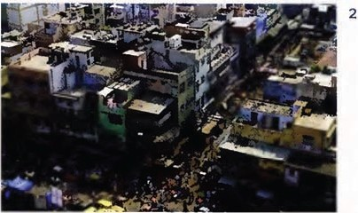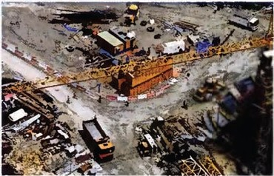1

Peshawar,on the Pakistan/Afghan istan border
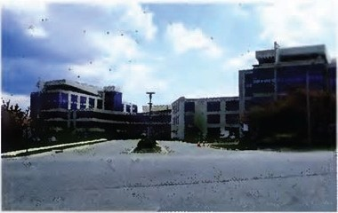3
Industrial development zone, New Orleans

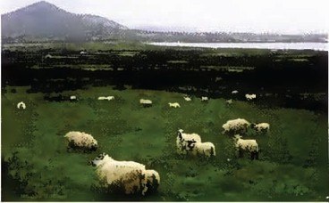4

Business park, near Heathrow airport, London Remote farmland,Ireland

DATA CENTRES

AUDIO

15
1 Rupert Wilson. CIO of a small investment bank, isvisiting a German data centre to find out about the services they offer.Helmut Schwartz is taking him on a tour of the data centre. listen to the first part of Helmut's tour and say if the following statements are TRU E (T) or FALSE (F).
- The data centre is in a German city. D
- The centre is closed for four days a year. D
3 Security at the centre is extremely tight. D
4 Senior managers do not need to follow allthe security rules. D
5 The data centre is connected to two different network POPs. D
6 The centre always uses its own independent power supply. D

40 I UNIT S Data centresand security

2 listen to the talk again. Complete the notes about what Helmut says,adding at least two items for each section of the diagram.Seethe example.

Security arrangements

location
Bavarian countryside
Far from airports/flight paths Raised plain

DATA CENTRE
/

Power

Most extreme threats/ dangers Connectivity

AUOIO

16
3 listen to the second part of the tour. Match thewords in the box with items 1-10 in the diagrams.

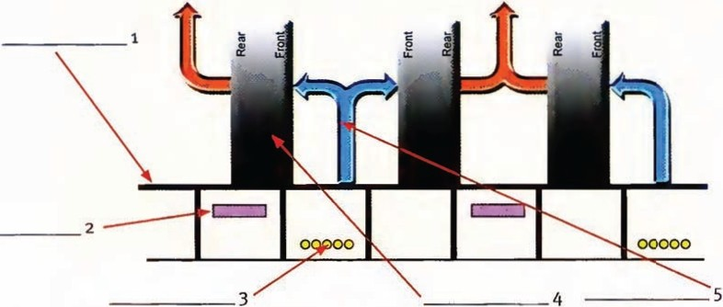
.

- 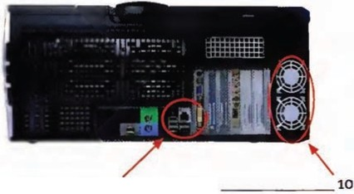I r

-..-....-.--------·- -- - - ·•
0
•
0
I I I ]

•

__ 6 7
9
_ 8

19-inch rack • alarm LED • blades • telecom cable trays • cold aisle • cabinets
- raised, perforated tiles • power cables • Ethernet port • fans

UNIT 5 Data centres and security [ 41

4 Match the words 1-11from the listeningwith the definitions a-k.
- mission critical a sections of a centre sealed off from other sections
- redundancy b using physical characteristics (e.g. fingerprints) for ID
- downtime c one weakness that could stop an entire system
- compartments d time when the equipment is not functioning
5 resilience e duplication of equipment in case one part fails
6 separacy f extremely important
- network outages g ability to withstand unexpected problems or setbacks
- power feeds h lack of electricity
- power cuts sources of electricity
10 single point of failure j having different and unconnected cables to a network
11 biometrics k times when a network is not functioning

Now work with a partner. Ask and answer questions usingsome of the words above.

- In your work, what sort of data is mission-criticial?
- How important is redundancy for the protection of data?
- What elements do you think are important for the resilience of a Tier 4 data centre?
- How might a Tier 1data centre differ from a more secure one?

AUDIO

Listen to the discussion Helmut and Rupert have after the tour.For questions 1-5,choose the correct alternative (A or B).

- Rupert says he:
A is keen to start outsourcing as soon as possible. B has concerns about making such a bigdecision.
- Rupert wants to know:
  - what would happen ifthere was downtime duringa trading period. B ifit is possibleto avoid downtime completely.
- Helmut tells Rupert that:
A they have never had any management problems. B they have never had a comms outage.
- Accordingto Helmut, a power outage: A would not cause any disruption.
  - could be fixed in a matter of minutes.
5 The mirror site in Switzerland:
- has a copy of allthe data at the centre.
- would warn the centre about an earthquake.

42 I UNIT 5 Data centres and security

TALKING ABOUT IMAGINARY SITUATIONS

We often use the second conditional to talk about possible situations. If there was a comms outage, we would switch to the backup service. If we lost power, our own back up power systems would start.
We can also use other structures to talkabout imaginary situations.
Inthe event of one of your servers going down ...
Supposing there was an earthquake or you got hit by aplane, what would happen then? Should anything terrible occur, you would need to have standby communications links. If that were to happen, you would switch over to the hot standby site.

6 Match scenarios in A with solutions in B to make second conditional sentences .

A  1 | Scenarios  Ifone power feed failed, | B Solutions  use I other network POP
2 | If both power feeds failed, | temperature alarm I go off
3 | If anyone unauthorized tried to gainaccess, | isolate /change I straight away
4 | Ifone telecoms service lost connectivity, | be stopped I security guards
5 | If the air conditioning went wrong, | switch I mirror site / Switzerland
6 | Ifthere was a problem with one of the servers, | use I other power feed I grid
7 | lf there was a complete catastrophe like an | UPS system I generator
 | earthquake or a plane crash,
Now, work with a partner. Ask and answer questions about the scenarios. Example:
A What would happen if there was a long power outage?
B If we had a long powercut, we would use our own generators.

7 Work with a partner. One of you is an IT managerlookingfor a secure data centre,the other is a representative of a data centre. Role play the meeting.

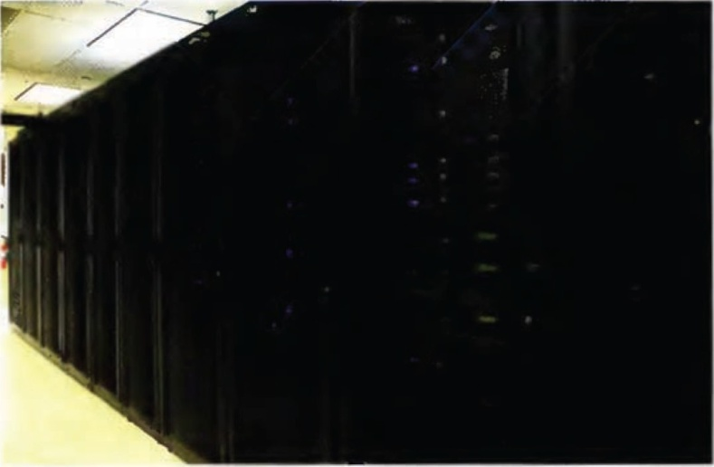

UNIT 5 Datacentres and security I 43

BANKING SECURITY

AUDIO

18
8 You are going to hear Jon, a banksecurity officer, answer some questions about hisjob.Before you listen try to complete the sentences about bank security.

spear • white-hat • worms • pingsweep • TCP/IP • certificates

- A hacker is a hacker who helps organizations protect themselves against criminal hackers.
- A is a process to check to see who is connected to a network.
3 fingerprintinggives information about what operatingsystem people are using.
4 128bit SSL ___ encrypt data.
s Anti-virus software can protect againstviruses and _
6 phishingis a more targeted form of phishing.

Now listen to Jon and check your answers.

9 These were the questions that the interviewer asked Jon.Listen againand match the questions
1-6 to Jon's answers A-E on the CD. There isone question that was not asked.

1 What can people do to stay secure online? _ _
- Is there anythingelse that people should be aware of? _
- How do you go about that? _
- Is itsafe to use credit cards online? _
s So, Jon, what sort of work do you do for the bank? _
6 What's the difference betweenyou and a normal hacker? _

- Read this short article about a computer infection.

Conficker has been in the news a lot recently. It is a 1
,
which unlike a

virus does not need to be attached to an existing program to infect a machine,anci which seems to receive regularly updated instructions from its controllers. It has created a
2 -a network ofinfected machines. Once infected, these machines are known

as 3 • At this point no one knows what the purpose of Conficker is. At present it has infected ten millioncomputers. These could beused for a 4 attack where all the infected computers attempt to access one site simultaneously.
Itis probably controlled by criminals who want to steal users' personal information,i.e. _
5 There are a number of ways of doing this: a 6 records information entered via a keyboard, 1 literally means harvesting users' information while they are online. We will probably soon see if Conficker consists of this type of passive monitoring 8 or whether it will mount a more active attack once it receives a new set of instructions.
•

- Work with a partner. Usethe information in your Partner File to complete the text.

44 I UNIT 5 Data centres and security

INFORMATION SECURITY
12 Read theintroduction to an emailandanswer the questions.
- Who is this email from (i.e. an employee,IT specialist, customer etc)?
- Who is the email to?
- What is the basic problem beingdiscussed?
- What will the rest of the email beabout?
- What kind of ideas might be in the rest of the email?

From: Rupert Hills-Jones To:All employees

Subject: Data Security

Dear All,
Unfortunately there have beenseveral instances recently of data falling intothe wrong hands. lhave been a victim of ID theft and we have lost a few company laptops and memory sticks containing sensitive trading information.The following rules around data and data security are mC11datory and failure to abide bythese will result in disciplinary action up to and including dismissal. Iam sorryfor the stern tone butthis is a very serious issue for usall.
13 Read the rest of the emailfrom Rupert Wilson,CIO of London Investments. Some sentences have been removed from theemail.Read the text and complete the gaps 1-6 with the sentences a-f
below.

- Ideally this should contain bothletters and numbers.
- Only company-provided and approved software may be used.
- At the end of each day, ensure that your desks are clear and alldocumentation or storage devices are in locked drawers.
- Do not leave them where they can be seen on the back seat of a car. e IT willbe runninga webcast on how to do this next Tuesday 251
h.
f Any documentation found lying around after the trading day will be destroyed. You have been warned.

Clear Your Desk
With immediate effect we will be running a Clear Desk Policy in the office.
1

Shred
All unwanted printouts, photocopies, notes etc. must be put into the shredders that have been installedin each office. 2
Use Passwords
All systems must be accessed using a password. 3• This password is secret to you and should not be shared with any other individuals .

UNIT 5 Data centresand security I 45

Change Passwords
All passwords must now be changed on a monthly basis. If you think that your password has been compromised, call the IT Helpdesk immediately.

Don't Download
All laptops are to be scanned on a monthly basis by IT to check for spyware or malware. Under no circumstances should any programs be downloaded from the internet onto company laptops.
Emails
Do not open emailattachments unless you know the originator of the mail personally and you are expecting an attachment of that type and name.
Keep Secure
All laptops taken out of the office eitherto clients· offices or to work from home must be kept secure at all times. !>
Memory Sticks
All memory sticks are now numbered. The IT Department will keep a list of memory sticks and who ls responsible for them.
Encrypt
All data stored on memory sticks must be encrypted. _ 6

And on a personal note if anybody sees my wallet, could you please pop it into my office. Regards
Rupert

Confidential.Internet communications are not secure and therefore London Investments does not accept legal responsibility for the contents of this message. This email and any attachments may be confident ial. They may contain privileged information and are intended for the named addresse (s) only.They must not be distributed without our consent.If you are not the intended recipient please notify us immediately and delete the message and any attachments from your computer. Do not disclose, distribute or retain this emailor any part of it.We believe but do notwarrant this email nd any attachments are virus free.You must therefore take full responsibility for virus checking.

14 Match the verbsin A with the wordsin Bto make expressions from the email.

//,

A  1 | be | B  anemail attachment
2 | change | a document
3 | download | a program
4 | open | a victim
5 | run | a webcast
6 | scan | alaptop
7 | shred | a password

46 I UNIT S Data centres and security

15 Now completesentences 1-7with the expressions from exercise 14. You may need to make changes to the verbs.
- Why canit be dangerous to _ _ _ ifyou don't know who sent it?
- Why is it important to _ _ like a bank statement that contains personal information, and not just throw it away?
- How often should you ____ or a desktop for spyware and malware?
- Why can it be harmful to_ from the internet and run it on your computer?
- Why is it a good idea to -------regularly even if there's no evidence it has been compromised?
- What are the advantages of _ as opposed to having trainingseminars?
- Have you ever of ID fraud?
16 Work in pairs. Ask and answer questions 1-7above.

GIVING INSTRUCTIONS

We often use the imperat ive to give instructions:
Ensureyour desks areclear. Usepasswords.
Donot leavethem where they can beseen.
We can also use a passive modal to giv formalinstructions.
Onlycompanyprovided and approved software may beused.
Thispassword should not beshored withany other individuals.
All laptops must bekept secure at all ti.nes. Underno circumstances should any programs be downloaded.

1] Usethe language from the box above to write a short emailto the members of staff of a company.
Think of three or four bullet points under the heading.(Phishing Isthe fraudulent stealingof information about bank accounts, PINnumbers, passwords, etc).

How to avoid phishing
•
•
•
•

UNIT S Da acentres andsecurity I 47
- Read the article about Telecoms and ITin finance and answer the questions below.
The Impact of Technology on
Global Stock markets
Theperiod of time between a trade being initiated and its completion is called latency - a key parameter for everyone Involved in trading.

efore technology was introduced, the average number of daily trades at
B
the London Stock Exchange was 20,000, amountingto about £700m worth of shares changing hands.After the introduction of automated trading, the figure went up to a daily average of 59,000 trades. This year saw nearly
£18bn of transactions in one day.
'The speed and volume of trading is much, much higher these days,• said Sebastian Kolksmann who works for London Investments
in Frankfurt.'Transaction flows are faster driven by end investors, by electronic trading, algorithms, and lower latency.'
'Time is money as they say,' commented Bob Sherunkle, a New York Trader for London Investments. 'If our technology gets me information a nanosecond faster than everyone else, Imay be able to sell a stock quickly, a split second before its price drops, or Imay be able to buyanother stock before its price starts to rise andit's more expensive for everyone else. That's why we need the fastest connectivity, the quickest processing, and the lowest latency out of our systems.·
So where do all these data transactions happen? Each exchange will have its own data centre that stores all the historic and current tradingdata with inputs, buy and sell requests, or market information, comingfrom all over theworld. Tradingcompanies are now
starting to host their own server equipment at the stock exchanges' data centres, providing sub-millisecond access to the trading systems and market data, thereby eliminating network latency.
For member firms that are coniected to Stock Exchanges via 100 megabit IP connectivity, collocatingtheir servers could
reduce roundtriptrade execution and market data transmission times by another one and a half milliseconds. Typically transaction capacity at exchanges is around 20,000 continuous messages per second and end-to-end execution latency for a deal is from about six milliseconds to three milliseconds.
Watchingall this goingon in dealer rooms around the world are the traders, surrounded by numerous screens showing red and green numbers and banks of phones allowing them to receive instructions from their clients to buy and sell, and effect those requests usingtheir computers or callinganother tradir€ house.
Just one exchange such as Londonwill have more than 100,000 screens connected directly or Indirectly to its data centre and trading systems. Of course, some dealers may be really putting IP networkingtechnology to good use and have the same data on their laptop screen, while they are sittingon a beach somewhere in
the world,tradingvirtually.

- What was the main effect of the introduction of automated trading?
- Where are more and more trading companies now keepingtheir servers?
3 How many messages can typically be sent per second?

OVER TO YOU
- Doyou think the technology mentioned in the article willmean the end of centralized stock exchanges such as London, Tokyo, and New York?
- What are the security risks of havingso many sensitive transactions happeningonline?

4s I

Services

look at the profiles of these organizations. Foreach one, note down at least one advantage and one disadvantage of outsourcing its IT requirements to a Managed Service Provider (MSP).
STARTER
For each company,think about these questions:

  - How complex are the company's ITand networkingrequirements?
  - To what extentis technology a core competence of each company-is technology something linked to the company's business?
  - How important are issues like privacy I confidentiality / security?
  - Can the company support the cost?

Maxland is a real estate company that operates in Southeast Asia. It has recently acquired severalsmaller competitors and now has offices in every state. It contacts clients through local advertising, databases, emails and has details of every property for sale on its website.

The Dressing Room is a small boutique specialising in clothes and accessories for women. It is a family business with only one store and the proprietor has little knowledge of IT.

G-sott is a start-up company in Korea that is developinga range of language learning DVDs and games. The office has five programmers and there is a team of 15 other freelance sottware developers and language teachers who also work for the organisation.

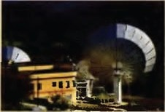Olympus Z1is code name of an operation that gathers intelligence from a military base in the Eastern Mediterranean. The team
intercepts radio and email communications and passes the details back to the security services.

,...,....l5

UNITS Services I 49

MANAGED SERVICES
1 ThaiManagement is a Managed Services Provider that offers three different levels of service to customers. Read the advertisement below and match the three levelswith the word that best describesthe service.
Managed Reactive Proactive

2 Labelthe services offered B- Bronze, S- Silver, or G- Gold.
- includes the supply of new equipment
- deals with problems within four hours
- offers a helpline duringthe day only
- offers the services of a manager probably shared with other customers
- is the cheapest
- deals with faults only after they happen
- has the shortest contract term
8 includes an optionalbuyback of equipment

ThaiManagement's Bronze package includes:
- A freephone Helpdesk number for you to report allyour faults during normal business hours
- Experienced service agents responding to your callwithin30 seconds
- Management of your fault with our market-leadingtrouble ticket system
- Qualified field maintenance engineers who are fully trained and equipped to fix your faults
- A guarantee that we will respond toyour fault by the next working day
- All available for a low-cost service fee payable monthly
·A minimum contract term of three years is required
Silver
ThalManagement's Silver package includes:
- Same day response to technology faults reportedto our Helpdesk
- Service agents will take your calls duringextended business hours (seven days aweek!)
- Proactive Fault Monitoring -our agents will test and pingyour equipment andservices on a regular basisto spot problems before you
do
- Performance monitoring of your network to find any bottlenecks or cost-saving opportunities
- Monthly Service Reports allowing you to spot trends inusage and problem areas and plan better tor the future
- A ThaiManagement Service Manager assigned to your account, responsible for your totalservice experience
- A minimum contract term of five years is required

ThaiManagement's Goldpackage includes:
- A dedicated team proactlvely monitoring your equipment & services for faults 24 hours aday, seven days aweek
- A fast, fourhour guaranteed response to all faults reported 24n
- Performance and utilisation monit0<ingof all your network and applications to ensure users get the experience theywant
- Realtime reporting provided online,enabling you tosee what's happeningwith your technology infrastructure at all times
- A dedicated ThaiManagement Service Manager just for your business
- Buyback of your existing infrastructure as part of the agreement
- Technology refresh on an annual oasis during the service contract
- A minimum contract term ot five yearsis required

50 I UNIT 6 Services

3 Work in pairs or two teams to playthe game.Student A (or Team A) should try to answer
questions 1-7.Student B (or Team B) shouldtry to answer questions 8-14.The first person (or team) to answer their questions is the winner.
Find words or phrases in the text that begin with the letters in the question. See the example. Example: What F.H. isa place you can call for advice and help at no cost?
Answer: freephone Helpdesk
Questions for Student A I Team A:
- What F.M.E. means experts who travel to acustomer's premises to fixproblems?
- What W.D. usually means any day except the weekend?
- What T.T.S. is a method for managingand respondingto faults that are reported?
- What E.B.H. means more thanjust 9 a.m. to 5 p.m. (e.g.6 a.m. to midnight)?
s What S.D.A.W. means every day?
- What M.S.A.is an agreement between a customer and a service provider?
- What 0.A.A.B means once a year?

Questions for Student BITeam B:
- What P.F.M. means looking forproblems before they happen?
- What S.F.is the price a customer pays every month to receive benefits?
10 What M.C.T. isthe shortest period that an agreement lasts?
- What S.D.R. means dealing withaproblem within 24 hours or less?
- What M.L. is anadjective that means best selling?
13 What C.S.O. means chances tosave money?
14 What T.F.S.are numbers that mean all the time withno interruptions?

4 An agent from ThaiManagement is talkingabout the service the company can provide.Complete the sentences with the words and phrases from the box.

buyback • dedicated • fix • pingtest • proactive • response • service • monitor

1 We offer a__ __ service, which means that we try to predict and prevent fau lts rather thanreact to them.
2 Ifwe can't __ a fault immediately, we willreplace the equipment.
- Under our scheme, we purchase allthe equipment you are currently usingand then upgrade it as necessary.
- We will run a on your equipment regularly to check that everythingis working properly.
- You can have a manager who willbe personally responsible for looking after your business.
- We offer a very fast ___ to any faults that you report to us.
- We will your network and equipment 24/7 to ensure that everything runs smoothly.
- We offer a range of different _ level agreements.

UNIT & Services J 51

COMPARING ADJECTIV ES

We compare one syllable adjectives and two syllable adjectives ending in-y by adding-er or -est
{the end -y becomes an-1).
TheSilver service is cheaper than the Gold service. TheBronze service is the cheapest.
Letting aservice provider manage your technology is easier than doing it yourself.
We compare longer adjectives with more ...than or ...the most ... TheSilverservice ismore expens ive than the Bronze service.
The Gold service is themost expensive.
We can also make comparisons with as ...as, without changing the adjective. Equivalent: Thecontract term is as tong for Silver as it isfor Gold.
Negative:TheBronze service is not asgood as the Silver service.
Qualified:The Silver service is almost as expensive as the Gold service.
There are a number of common adjectives that are irregular.

good | better than | the best
bad | worse than | the worst

5 Look back at thefour organizations in the Starter on page 48. Make comparisons about them usingthe words in brackets.See the example.
The Dressing Room is l_he smal_le_s..t_ (small) company.

1 | The Dressing Room's IT requirements are | (not complex) those of Maxland.
2 | The Dressing Room is probably | (easy) to manage thanthe other
 | organizations.
3 | Maxland's website is probably | (big) than any of the others.
4 | Maxland's employees are probably | (not/computer-literate) as the staff at
 | G-soft.
5 | Ofthe four organizations, G-soft probably has specialists. | (good) in-house IT
6 | G-soft's web presence is probably | (not/extensive) as Maxland's.
7 | At Olympus Z1, security is | (important) it is at G-soft.
8 | In fact, at Olympus Z1, security is probably | (critical) issue.

6 Look back at the three levels of service offered by ThaiManagement. Make comparisons about the Bronze, Silver, and Gold services using these words.

1 comprehensive
2 suitable for a smallbusiness
- high monthly fee
- long service contract
- fast response time
- personal service

52 I UNIT 6 Services

SERVICE LEVEL AGREEMENTS
7 Look at the home page for lnterAsia Car and make notes on:
1 who lnterAsia Car's customers probably are.
2 how lnterAsia Car probably attracts most of its customers.
3 three ways in which a Managed Service Provider might be able to help lnterAsia Car.

When you have finished, discuss your note.s with a partner or insmall groups.

HOME lnterAsia Car
lntcrAsLl Dr isa family owned and reasonably prked car and motorbike rental

Car and Joep Rental Motorbike Hire
Terms and Conditions

Contact Us

Online Payment
ny in Thailand .With our good range of well maintained and Insured urs and jeeps. you un enjoy your stayand explore Thailand the easy way.
We have offkcs at all the major airports In Bangkok,Phuket. Samul, Patuya and offer a drop olf and pick up service anywhere In Thailand.
lntcrAsLl Dr has been in operation since 2006 and Isone of Th•lland'sfastest crowingcar rental operators.

Why choose InterAsta Carl
- All our rental cars. jeeps, motorcycles are maintainedto the hl&hest staiwlards.
- Honest. reliable, friendly nr rentalbusiness.
- Nohidden extra costs-wlut you sec iswlut you pay (we. Insurance all included
Inrental rates

8 The management team at InterAsia Car are havinga meetingto decide what they might need from ThaiManagement. Chen the MD istalkingwith Anurak, his ITdirector and Betty, the Customer Service Manager.
Readthe comments they made about the table of services on page 53. Try to niatch the comments below with the rows a-Iin the table.
1 It's important that we have it 24/7 like the Gold Service, but we don't need a dedicated team ...
2 Do we really need that -surely we're in the best position to know what needs replacing?
- It'svital that we have cover sevendays a week.
- As long as there's someone who's familiar with our infrastructure, then Ithink a shared one would be fine.
- If we have user or customer service problems because of our technology then we need to be able to see what's goingon there and then.
- Our applications are pretty simple; Idon't think we need it for them.
- ...we can manage that, no problem, but the Gold is more than double ...
- ...we're very busy Saturdays and Sundays with people hiringcars at the weekend. We need at least the Silver Service ...
- But boss, that means we'dlose control ofour lT.

AUOIO
9 Listen to the meetingto check your answers.

UNIT S Services I 53

NEGOTIATING AN SLA
AUOIO
® 10 Chen, the MD of lnterAsia Car, istrying to negotiate a deal with Maliwan, the Sales Director
20
from ThaiManagement. Listen to the dialogue. Circle the elements of the Silver Service and Gold
Service in the table below that Chen and Maliwan agree on. See the example.

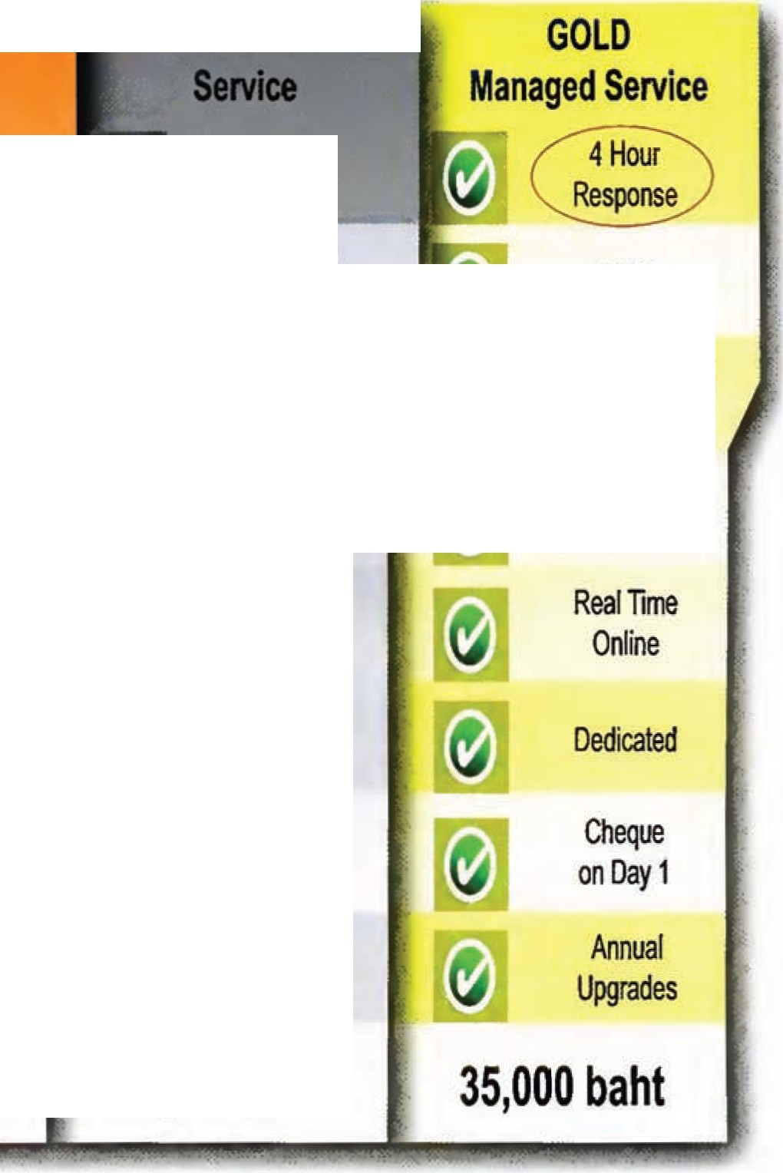Maintenance Cover
BRONZE
Service
Next Working Day
0900-1700
Mon-Fri
GOLD
4 Hour
Response
0800-1800
7 days
24fl
Shared Team
Business Hours
Dedicated Team
24[1
Network Only

Monthly
Network &
Applications
Real Time Online
Shared
Dedicated
[9]
[9]
16,500 baht
Cheque
on Day 1
Annual
Upgrades

7000 ba ht 35,000 baht
a (Break/Fix)

b Helpdesk Availabmty

c Fault Monitoring

d Performance Monitoring

e Reporting

f Service Manager

g Asset Buyback

h Technology Refresh

Monthly Price Per Unit

11 Listen to the extract again. Say who uses the following expressions. For Chen, write C, and for Maliwan, write M.

1 ..• the SLA we are looking for is ...
2 We can manage that
- The only thing is ...
- How do you suggest we deal with that?
- I'llhave to think about that
- How does that sound?
- I'llmeet you in the middle
- Let's shake on that.

54 I UNIT 6 Services

NEGOTIATING

Askingfor suggestions What can you do about that?
Howdo you suggest we deal with that?

Delayinga direct answer I'llsee what we cando.
1'11 have to think about that.

Askingfor reactions toa proposal Would you consider ...
How does that sound?

Talking about needs We require..•
I'd like to talk you through what we are after. What we are looking foris •..

Give andtake
If you ...,then Icould...
We can do that ...,but only ifyou also.••

Indicatinga problem Yes, but...
The only thing is ..

Compromising Let's compromise.
I'll meet you in the middle.

Agreeing
OK Idon't have a problem with that. OK that's not a problem.
Ican accept that.
We can manage that

Confirmingan agreement We have a deal
It's a deal.
Let's shake on that.

12 A customer is talking to an MSP. Put the following dialogue into the correct order. The first one has been done foryou.

D D
a | Customer | Hi,yes that's right. Thewebsite itself is fine, but what weare looking for is a way to cut costs a bit. How would you feel about reducing the monthly fee?
b  c | Customer Provider | 5% isn't that much but, OK,I can accept that.  All right, let's compromise -if you go for weekly updates, then we could
 |  | cut the fees by 5%.
d | Provider | Great. It's a deal.
e | Provider | Hi,Jason, Mr Ange/is said you wanted to talk to me about changes to
 |  | the website.
f | Provider | I'll have to think about that. Theprice you're paying at the moment
 |  | is already very competitive.
g | Customer | Not really ...the thing is that weneed it updated more than once a month.
h | Provider | Ok, then, wecan probably give you something a bit more affordable if we
 |  | cut some of thefeatures. Would you consider monthly updates instead
 |  | of daily ones?
 | Customer | Yes,Iappreciate that, but theproblem is that wereally can't afford it,
 |  | and I'mnot sure we really need all the services you're providing.

D
D
DJ
D

D

D

1J Work with a partner. Look at the Negotiating phrases above and the information in your Partner File. Role play the negotiation.

- Read the negotiatingtips and answer the questions below.
UNIT 6 Services I 55

S Top Tips for Negotiations

These are tough times for IT. There are fewer
people to get things done, budgets are shrinking and everyone still expects the same levels of service and functionality. But even
in this tough, budget­ conscious economy there are still some purchases that have to be made and contracts with Managed Service Providers that have to be renewed. So how do you ensure that you are getting the best value for
money?

Mortin Ewing is the principal
at Poctoris,Inc Hehos worked
1n the IT Industry for nearly 30 years and was the CIO ofa
mult.ibillion dollar corporation before founding Poctorisin 200 I .
His com(><Jny specializes in IT
cost reduction and IT contract negouotions.
DGet the Right People Involved
In today's complex world. technical skills and negotiating skills are both crilical. Anyone negotiating software licensing, maintenance and other technology contracts needs to understand the details ofthe
technology. Similarly. a negotiatorneeds procurement skills and enough experience to be comfortable withthe negotiation process. Make sure that anyone talkingto thevendor has both skills, even if it meansgettingoutside help.
IIFear,Uncerta inty and Doubt (FUD)
Vendors are noL frightened of purchasers any more.and some of he traditionalhard-nosed procurement and negotiation methods no longer work. What makes vendors really uncomfortable is not knowingwhere they stand. So,say you arc consideringalternative solutions. but don't give out too much information.Hint al competition or alternatives. but don't threaten. Be as vague as possible and let them imagine the worst.
IJGet the Account Manager on board
We all know that you will only get big discounts if lheseniormanagement of the vendor's company approve.We also know that the person who best knows the approval system is the salesperson trying to sell toyou. Ifthey think they can get a sale by meeting your terms, they will become your best ally and most powerfulweapon ingettingyou what you need. Let them dothe work for you.
0Know Your Options
There is always competition, even when negotiating maintenance contracts.The key is to convince the vendor that you have a serious alternative. because you do.There are companies that speci l11ze in supporting third party applications, and there are also other alternatives, suchas self-support, reduced coverage.block hours the listgocs on. And when it comes to hardware, there are stillmore companies lhal can provide the same or even higher levels of service at a significantly reduced cost. So make surethe vendor knows you're aware of your options.
IIRemember to Ask
Anally, the best piece of advice is very simple: Don't be afraid to ask for a better price.Just remember. 1fyou don't ask -you don't get.

1 What two qualities does a good negotiator need?
2 What does the writer suggest instead oftryingto appear tough and aggressive?
- Why isthe salesperson so important in gettingyou what you want?
- Why are you not locked into maintenance contracts with a vendor?

OVER TO YOU
- Doyou thinkthat one or two countries will end up dominating the telecoms and IT service sector providingservices to the rest ofthe world?
- Why I why not?

ss I

Media

Look at the Images of howdifferent media can beused in advertising.Make notes on:
STARTER

  - which forms of advertisingare the most expensive.
  - which forms of advertisingyou have personally responded to.
--.,r
._
--
.,.

w.t
L .... ....
-""'" oj • ., •
.:J.--p _,....
,., ....,.....,.,..,............._
INDUSTRIAL C\.EA NERS
_............... ....,. ,,.c;.,......
.............. ............. .....,..
. . .......
_
...,...,_,.., _.._ .........
_ ,__ -
_...,.
. ...
.......
_ _
,..,,..."'-...
,._ ...
! ---·--
..........,,.. ..,........
,....
___
1
....
....................
.....
_
-.
..
-
..
.
..
-·
-
.......,.
-
_,
.
,.
.
-
.
...
I:..:..-......:..;....:..... ......
,........... ........................................-...-.....
-----··-
_._..,.,•.,.,,1\ C.............. ..,..
......................_....-..-.........
Pay per click advertising

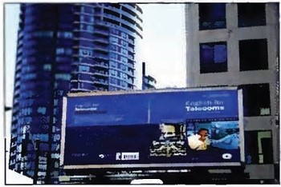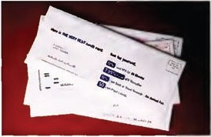Direct mail Billboards
TV advertis ing

Now discuss your answers with a partner.
Read these situations.In each one, say which form of media the followingpeople/organizations could use to contact their target audience (use your answers from the activity above and other ideas):
  - the owner ofa holiday home who wants to advertise that the place is available to rent for part ofthe year.
  - a major manufacturer of confectionery who wants to promote a new chocolate bar.
- a single person who has just moved to a new city and wants to make new friends and meet up with any old ones who may live in the area.
- a cigarette company that wants to improve sales {direct advertisingby tobacco companies is against the law, even on the internet).
s a hardware company (with a database of customers) that wants to sellitslatest notebook.
6 a supermarket that wants to wa rncustomers that some tins offish that it has sold recently may cause food poisoning.

UNIT 7 Media I 57

llHG?1(.Jil

1 Complete the table with details about you and your country.

Who are the TV broadcasters? Who are the IPTV providers?
What's the name of the TV service from the national PTI?
How do you receive television? How many channels can you get?
How do you pay for television-annual licence I monthly subscription I pay perview?
How much do you pay (e.g.monthly TV costs compared to monthly telephone costs)?
How have / willthese amounts change?

Now compare your answers with your partner.

TECH TUTORIAL

CRT = Cathode Ray Tube
The light source inside older TV sets ORM = Digital Rights Management
Similar tocopyright for electronic content EPG =Electronic Programme Guide
An electronic list of programmes available on TV, cable, satellite, or the internet
IPTV = Internet ProtocolTelevision Digital TV over a network
LCD = Liquid Crystal Display
The technology usedin flat screen TVs and monitors
MPEG =Moving Picture Experts Group A file format for audio and video
VOD ..Video On Demand
Playback ofvideo at request of user

2 You are going to read a text about changes in television .Before you read, try to complete the notes on some of these changes.Complete the table with the pairs of expressions.

broadcast to all I download on demand • all scheduled I time shifted • antenna / broadband • TV licence or advertising/ pay perview • CRT I LCD

From
to rec.eive 1 to view 2 transmission 3 business model
sc.hedule 5

58 I UNIT 7 Media

3 Now read the text to check your answers.

PLAYING CATCH-UP

ntil very recently television broadcasting had been mostly
U
unchanged since the 1950s. Broadcasting has longused antennae to transmit images and sound using the radio spectrum. A receiving antenna, usually on the roof of homes, receives the signal and demodulates it to provide the sound and images to a cathode ray tube (CRT). Viewers had
to watch progt·am mes according to the transmission schedule set by the TV broadcaster and use a video tape recorder to view programmesthat they missed.
But the rapid increase in digitization and broadband networking haschanged all that. Now content makers large and small, old and new, can use the internet
or IP networks to distribute content. IPTV can provide live multicast TV services to a number of users, normally subscribers to a service. A unicast VOD service provides the playback of video to the viewer's set-top box or computer.
The key advance that has enabled these services is the massive increase in low-cost broadband services into homes. In the past, lack of bandwidth restricted the use of video over the internet,but now
content can be compressed into MPEG-2 or MPEG-4 formats, broken into IP packets
and streamed across the networks into people'shomes. Here it is decoded by a set­ top box or played back with a media player on a PC. This is all having an impact on viewing habits. Presented with an EPG containing not only today's programmes but last month's, viewerscan now watch things when they want to watch them, not when broadcasters want to transmit them.
Even during a programme viewers can pau se or rewind to see the goal they just missed, or listen again to the point made in a documentary. And if they do still miss a whole pt·ogramme, they can record and
store the data on the hard disk of their PVR (Personal Video Recorder).
Even the business models are changing,
pay per view is already commo::i and may yet replace the income from ad·fertising or licence fees .Viewersarc now watching content on LCD flat screens, PCs, or even mobile phones instead of bulky CRTs.
Two problems are created by all of these changes. Content makers worry that digital content is easily copied for free, although digital rights management provides some protection.Advertisers are now worried their content isn't watch ed at all as the viewers now have so much control they can fast forward through adverts.

4 Look through the text and find words that mean:
1 an aerial
2 the full range of radio frequencies
- a piece of equipment that candecode digitalsignals for a TV set
- a piece of software for playing audio andvideo files
s a method ofchargingviewers based on what they watch
6 a fixed annual fee for owninga television set

5 Answer the followingquestions usingsome of the words above.
1 How does a traditionalanalogue TV signal get to a viewer's set?
2 How does a digital signal get to a user?
- How canviewers record programmes or see what they have missed?
- How can content providers or broadcasters make money from viewers?

UNIT7 Media I 59

6 Match the means of transmission to the definition. Then match them to an exampleof a leading provider from Britain.

- unicast
- multicast c broadcast
  - closed transmission to a group of users
  - open transmission to anyone
3 transmission to a single user
A BBC
B YouTube
C Sky

Now think of an example of a leading provider from your country.

7 Look at these examples of words that can be usedwith the word signal or content.Complete the diagrams with words from the text on page 58.
------

tr4nsmil ... A SIGNAL

8 11
CONTENT
maKer 12

6 10

8 Complete these sentences usingsome of the expressions from exercise 7.
1 A lot of__ _ are concerned that their programmes are being copied illegally.
2 Itis important for a national broadcaster to be able to _ _ to
every part of the country.
- MPEG techniques make it possible to ___ into much smaller files.
- A PC media player can the in MPEG, wmv and MP3 files.
s Digital rights management allows film-makers to _ _ to a certain extent.
- Most TV viewers still needan aerialpointing in the right direction to _ _
_ from the national broadcaster.
- A CRT creates images from the it receives from the antenna.
- As broadband capacities have increased,it has become easier to . ___ across networks in IP packets.

60 I UNIT 7 Media

9 Mark each line with an X to show approximately where your country ison the spectrum of TV services.See the example.

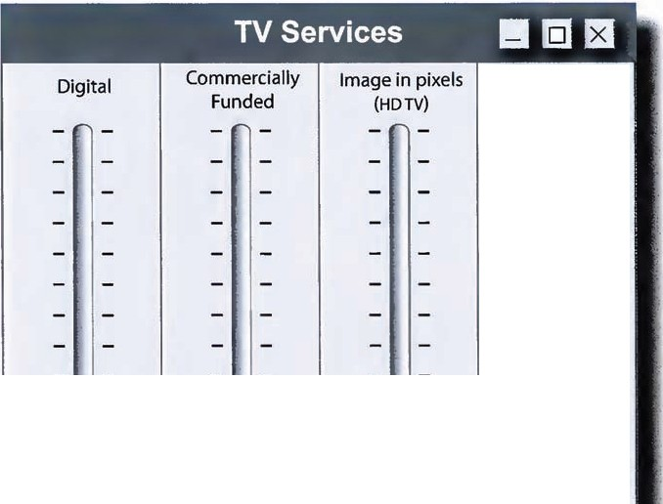
Unicast
Analogue
State Funded
Image in lines
(PAUNTSC/S ECAM)
Broadcast
What type of
TV transmission
is most common?
WhichTV
funding model is most
common?
What picture How are most
quality do most programmes users receive? received?

When you have finished, compare your answers with a partner and discussthe questions below.

- When do you think that TV transmission willbe 100% digital inyour country?
- Doyou think that TV will ever be entirely commercially funded in your country?
- When do you think the choice ofwatchingTV on a computer or accessingthe internet via a TV will be irrelevant?
- Doyou agree that the Unicast model causes fragmentation in TV viewing? What effect does this
fragmentation have on the culture of TV on society when there are fewer bigTV moments that large proportions of the population will have seen?

UNIT7 Media I 61

MEDIA START-UP

10 Start-up companies often need to raise money before they can launch a business.Make a note of one advantage and one disadvantage of each of the followingways of financing a new business:

1 Usingall your own money
2 Raising money from family and friends
- Borrowing money from a bank
- Raising money from a Venture Capitalist / Business Angel
Advantage Disadvantage

When you have finished compare your noteswith a partner. Discuss any realcompanies you know of that have raised money and explainwhat choices they made.

AUOIO

21

11 AdVentureUS are a venture capitalcompany that specialize infunding international technology start-ups. You are goingto hear three companies pitch for investment.
Listen to the first pitch. Complete the notes about the company and its business model.

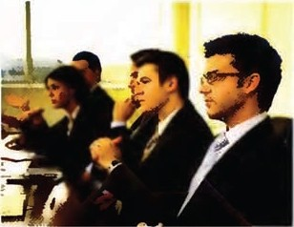Name: __
Main area of business: _ 2

Revenue streams
3 Registered users afteryear1:-----­
4 Registered users after year 2 : 5m
5 Registered users afteryear 3: 8
6 Current stage of development: __ 9

12 Complete the questions that an investor might ask with words from the box.

account • banners • domain • e-commerce • hosting • mailing • messageboard
- monetize • prototype • social

1 Are there any other networkingsites for pet owners on the net?
2 Who built the that you are usingto test out the idea?
- How do you access the to arrange walks with other localusers?
- How else could you this and make iteven more profitable?
s How easy is itto register and create an ?
- What other products will you sell in the section?
- How much are you planningto charge for your advertising ?
- Who are you planningto sell the list to?
- How much did it cost to buy the name?
10 Have you had any figures from the third party company?

Now listen againto check your answers.

62 I UNIT 7 Media

AUDIO

22

13 Notedown answers to the questions inexercise 12 - use information from the text or invent any missing information. Nowwork in pairs.

Student A: You represent theventure capitalists.Ask the questions.
Student B:You represent Lamppost.com. Answer the questions.

14 Listen tothe second pitch.Complete the notes about the company and its business model.

Name of company: Area of business: ____ 2

Main marketa Income
a Sign upfee: __8
Monthly subscription: 9

Reason for needing funding:
5 Sale of game in stores: 10

Time for product development: ____ G
Time for testing and trialling: -------

15 Complete this email from one of theventure capitalists to a colleague.
consoles • controllers • graphics • joysticks • keyboards • networked • streamed
- open source

Hi Jason
We've just hadsome people into sellus an idea and Ithough I'd run it pastyou asthis is more your field. Basically they've puttogether ateam of ' video gamedeveloperstocreate a globally-
__ _2 war game that willbe 3 across the internet.Thisisaimed notjust at peoplewithgames 'butalsoat PC users with a reasonable ______ card, makingthe potential audience a lot bigger. Myworry is that most PCuserswon't have_ _
norgame 7 to move around the screen,but I'm notsure how important that is.
8 are fine for typing, but how easy is it to control avatars withthem? Best, Alan
JI,.
'f'
a
Now listen againto check your answers.

16 Make notes onwhich of the companies you would invest in and why. Discuss your notes with a partner.

UNIT 7 Media I 63

WEBSITE USEABILITY
17 Match the words with the definitions.
- jpeg I gif a a word, symbol,or image representinga company
- a tab b an area that takes users to a separate page when it is clicked
3 block oftext c an area of the screen with an advertisement
4 row d a vertical section of the screen
- mock-up e a horizontal section of the screen
- banner f commonly used formats for photographs
- logo g an area of the screen filled with words
- column h a working model for demonstrat ion or testing

AUDIO

18 Listento Juan from Lamppost.com talkingto a designer. Match the features a-e with the correct blanks 1-5 on the screen.

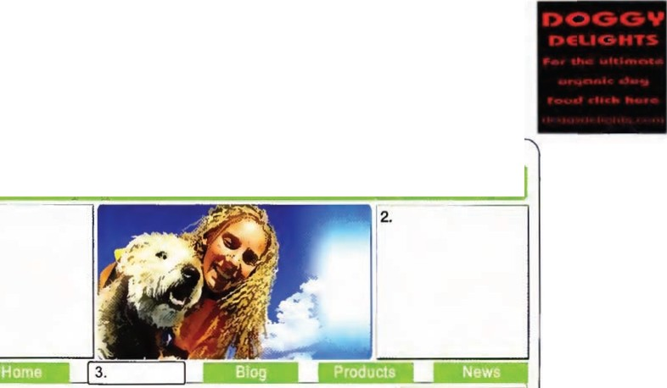
a
·••·
b
c
d
e
•lfl
Lamppost
.com
1.
Welcome to Lamppost.com
the socialnetworking site for dogs and their owners!
we hope t.e new website w11 be a great help with au your oog·s needs
Our new ventures include regular news updates and sooa network ng for you to tel usaD how much
you 1011e your dog
5.
4.
41@1111
Username
I I
Password
As our Ve1> a quest on to y:>1..r dogs prob
and we will ema you r 91bac
Forgot your passwocd?

When you have finished, compareyour answers with a partner.

64 I UNIT 7 Media

19 Listen to the dialogue again.Say if the followingstatements are TRUE (T) or FALSE (F).
1 The designer has placed the logo at the top of the screen on the left. 0
2 Juan does not want advertisements on the home page. 0
- The 'Resources' tab will take users to the biogs. 0
- Regular users willhave to sign upevery time they use the site. 0
s The site will have an e-commerce facility for subscribers. 0
- Users can send an email if they forget their password. 0
- JPEGs work better than GIFs. 0
- Users willbe able to upload their profile details to the site. 0

DESCRIBI NG A PLACE

Look at the words and phrases we can use to describe the positions ofitems on a screen.

In the topleft hand corner Topleft  At the top on theleft | At the top | In the top right hand corner  Top right At the top on the right
On theleft | In the middle In the centre Centre screen | On the right
Inthe bottom left hand corner Bottom left | At the bottom | Inthe bottom right hand corner  Bottom right

20 Work with a partner.You each have a brief for the homepage of a website.Make a rough sketch
of the homepage, do not show this drawing to your partner. Using the words in the Language Box and exercise 17, describe the website's home pageto your partner and ask them to draw it.
When you have finished, compare the drawings.

m Read the article about news and answer the questions below.
UNIT 7 Media I 65

MANAGING NEWS IN THE DIGITAL AGE
Iam in the head office laptops, smartphones and Interms of information and of a leading Spanish digital cameras, although data, the news operation
newspaper, standing in reporters in war zones have manages hundred s of
the cavernous News Hall, sat phones aswell. terabytes. The organisation avast circular room where Like a one-man-band, has two data centres for
the silence is only broken each reporter can send digital disaster recovery reasons, by the quiet hum of the material to a site that feeds each with a few hundred air conditioning. All into the production system. servers. The website gets around, monitors flicker on The 600 editorial staff receive about 240 million page individual desks, and high this constant stream of news impressions a month, and
above is a giant screen that content along with reports there are 30 million unique continuously streams news from the Press Association, users split between Spain and feeds and headlines from Reuters and other outside Latin America.
around the world. agencies. The editorial team, As for the future, Mr
My host, the editor all Mac and Adobe users, Sanchez is confident that the Fernando Sanchez, takes then create the headlinesand paper willcontinue to ?rosper. me through the process stories and get them ready Theworld is changingso
of gathering news in the for the print version or the fast,' he explains, 'and people digital age. The newspaper's internet. are generating and receiving reporters are spread across The same news goes on news in so many ways now the globe, some in diplomatic both the newspaper and the - print, email, web, blogs, capitals, some in centres website. The print version Twitter, itjust doesn't stop. of commerce and some in is sometimes scaled down Ifa news business like ours is dangerous trouble spots. and shortened for the daily going to survive, we have to More often than not they publication; fuller pieces adapt quickly and embrace work either individually or appear on the website, a 24/7 new technology. And believe
in very small teams, relying operation where the content me, that'sju st what we intend on a simple combination of is constantly changing. to do.'

1 How has technology changed the size of teams of reporters?
2 Apart from its own reporters, what sources does the newspaper use?
- How does the print version ofthe paper differ from the online version?
- To what extent is Mr Sanchez worried about the effects of new technology on the news industry?

OVER TO YOU
- Are printed, daily newspapers going to disappear? What are your reasons?
- What will the media landscape look like in five or ten years time inyour country?
- Should music or other digital content be free?

66 I

Society

Read the quotes about technology .
STARTER

The factory of the future will have only two employees,a man and a dog. The man will bethere tofeed the dog. The dog will be there to keepthe man from touching the equipment.
Warren G.Bennis

When 1 took office, only high energy physicists had ever heard of what is called the Worldwide Web.... Now even my cat has its own page.
President BILL CLINTON

The purpose of medicine is to prevent significant disease, to decrease pain and to postpone death...Technology has to support these goals-if not, it may even be counterproductive.

Technology shapes society and society shapes technology.
ROBERT W.WHITE,1990. (S&S)

DrJoel]. Nobel
CoM-p1-<.ti.""g i.s ""°t t:1bo1-<.t coM-p1-<.ters tl""tj
1M.Ore. rt i.s t:1 bo1-<.t ti.vi.""0·
Nic0Lt:1s Negropo111-te

For o.. List of oJ.L tne. ws f:ed1nolo98 nas fo.iLe<i t.o 1.mprove. tl1e. qw.J of l.i,fe, pteMe. press tnre.e..

Discussthe quotes with a partner.
The real danger is notthat computers will beginto think like men,butthat men will beginta think like computers.
Sydney J. Harris

  - What do they say about the relationship between society and technology?
  - Do you agree or disagree with them?
  - Doyou find any of them funny?

UNIT 8 Society I 67

AUl>IO

24
iiiiJHilUll
1 You are goingto hear part of a weekly radio programmecalled 'Technology Today•. The subject of thisweek's extract is healthcare. Listen to the introduction and match the people with their roles.

- Lynn
- Malik
3 Imogen
4 Helen
5 Sue

a Hospital manager b paramedic
c nurse on cardiac ward d patient
e doctor in Accident and Emergency

AUDIO

25

2 Listen to the rest of the recording.For each person, underline two items that they mention.
- Lynn GPS laptop Sat Nav
- Malik database wireless LAN mobile phone
- Imogen CT scan X ray OICOM
- Helen RFID tag digitalclipboard VoIP
3 Listen tothe recordingagain. Complete the sentences with the missingwords or phrases.
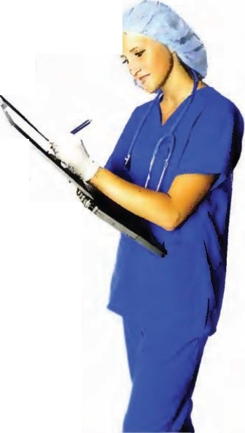1 She the emergency services,speaks to the
and asks for an ambulance.

;
2 The ambulance will her Health Number ahead,
and with that,all her details can be from the National Patient Records Database.
- The whole hospital will be _
so that with the correct security,

actually a
and

password, doctors or nurses will be able to _ a patient's records wherever they are in the hospital.
- Iwould visit her every day, and _ _
__ _ to the hospital systems using my
clipboard. The clipboard would recognize the tag in Sue's w ristband.
s She would then plug it into a _
and the data would be to a database in the hospital and added to her patient records. The would automatically display the data in a graph.

68 I UNIT S Society

4 Write short sentences to describehow the following pieces of technology were useful inSue's treatment and care.

1 GPS location
2 Radio
- National Patient Records Database
- Wireless LAN
s Datatablet
- RFIDtag
- Barcode reader
- Remote monitoring device

Now,discuss your answers with a partner.

THE PASSIVE

We often use the passive voice to describe processes, especiallyif we are more interested inthe action itself thaninthe person who does the action. It is formed usingthe verb to be and the past participle. We can use by at the end ofthe sentence to say who or what does the action.
Look at these examples from the extract:
Thehospital is connected to a national data network.
Weoredirected to thepatient automatically by the sat-nav using the most direct rou:e. She was brought in to hospital
All her details were downloaded from the National Patient Records Database
The passive can be usedin most tenses. Present Continuous
Sheis being treated forshock.
Future
Thenew system will beinstalled on the NHS network.
Present Perfect
Thepatient hasn't been examined yet.
The passive can also be used with modalverbs.
Hemustn't begiven penicillin.
Medical records can be downloaded onto a laptop.

5 Complete the summary of Sue's experience after her illness. Change the adive verbs in brackets to the passive.Use by if someone's name is mentioned. See the example.
When Sue fell ill,(they rushed her) she was rushed to hospital, and (they gave her)
- -----'emergency treatment as soon as shearrived.Then (they moved her)
- -----'to Kward, where (Helen looked after her) 3, (She visited her)
_ 4 every day, and (she monitored her progress carefully) \ (She recorded all the details of Sue's treatment) 6 on a clipboard, and (someone transmitted the information) ,to Sue's digital patient records.
Now Sue is back at home, where (they monitor her) 11 remotely. (A specialdevice measures her heart and blood pressure) 9 which transmits the data to the hospital, where (someone adds it) 10 to her patient records. (Someone displays the data)
- ------"on a graph for the doctors to look at, and if she needs more medication, (someone sends itout)_ _ .,automatically.

UNITS Society I 69

l11i;Wjliflit4M
6 Read through the statements.For each item, say to what extent you agree or disagree.
1= agree strongly
2 = agree
3 = not sure 4 =disagree
5 = disagree strongly

BigBrother iswatchingyou

1The police should have everyone's 123 4 s
DNA on their database.
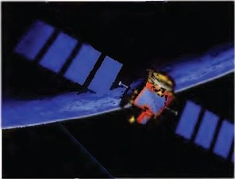2 Iam in favour of CCTV cameras 123 4 s
because they helpto reduce crime.

- The government should have the 12 3 4 5 right to record everyone's internet
activities

- The authorities should have the right to intercept anyone's telephone conversations.
s Biometric identity cards would be useful in the fight against terrorism.

- It's OK for data about personal shoppinghabits to be collected and shared.
1234 5

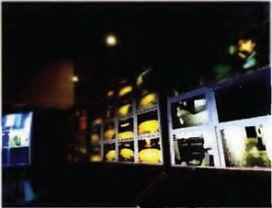123 4 5

1234 5

- 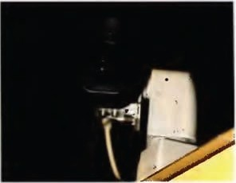We need more traffic cameras with 123 4 s
number-plate recognition to make the roads safer.

- Law-abidingcitizens need not worry about personal data that is collected about them.
12345

When you have finished, discuss your answers with a partner.

70 I UNIT 8 Society

7 Read the extract from a science fiction book on page71.
Doyou think it is fictional? Where do you think it is set?
Which of the methods of surveillance mentioned in the text are used in your country?

- Read the text again.Find at least eight occasionswhen personal information istaken or used. See the example:

Recording/surveillance agent
1 Traffi c cameras
2
3
4
5
6
7
8
Detailstaken
Time o(leavin9 in the car and arriving

- Match thewordsfrom A with their meanings from B in the context of the story.

A  1 observing  2 recorded | B  a b | made a note of given permission
3 calculate | c | Internet company
4 provider | d | watching
- logged  - authorised | e f | work out  recorded andwritten down
7 tagged | g | knew what (he) looked like
8 tracked | h | electronic till
9 recognised |  | stored andfiled
10 archived | j | followed
11 EPOS terminal | k | fitted with a tracking device

10 You are attending a conference on surveillance in London for f ivedays. You are stayingat a hotel near theconf erencecentre.As part of the conferenceyou have been set a practicaltask. You
must remain completely unobserved,digitally, for the next five days,whilestill attending the conference and other meetings.
Work with a partner and decidewhat you will do about:

avoiding CCTV cameras money
payinghotel and restaurant bills
security equipment at the conference centre keeping in touch on the phone
sending and receiving emails to your Head Office travelling round London

UNIT 8 Society I 71

I \\'<tS a11ollwr i.•, rey morning as \Vi11ston sl'I out on tlte journey lo the lr;i i n slation. He kepi gla ncin at t h · speedometer, ma king s11rc tha t h • dicl not (Teep over lhe limil, knowing Iha! the ramerns were always obset"\ing him. They had already re<'ordcd his rn1111bcr plate at the
I
start ol'joumcy am! 1rnuld be able lo cakulatc ii' he bad heeu spce<li11g.
"At the nc.xt jundio11, lu111 ldi " the expressionless \'oice ol' thc GJ>S called oul, c1·e11 though he
had been making t he same rout e )()[· 1 .1years .
I'mlcr t he \\ 1trhfol ere of t he CTV, he fo1111<1 a spa('e i n t he station car park a safo distance from a sn1all gang of youths. s I n:locked t he rnr, l ie remembered l hal t he home broadband cont ra<"! needed rcncwini-:. Hequickly phoned his wile on his mohilc, explaining1ha1 l hc provider would know what package would suil t hem bcsl a. t he • knew how 111ud1 data the family used. His prcsenn!i n mohik:n.'11 D2-H2 J was log<.·cl al 7..J.9.
He hough! a T111·d Card, and he 11·as 11 1iting for his credit card lo be authorised, he notired one of the C 'TV opernlors in t he hark ollicc pointi ng lu a yo1111g ma11 011 tlic stTccn. lt was 011e or the gang lhat \Vi11sto11 had noticed, ;md he was llashi11g up as hci11g laggctl.
This, howt'\Tr, was none of his bu siness, o he bought t he daily paper and waited paricnl1y until the t rain slo\\'I}' rolled in. The t rain was 1101 full, so h ·sell) ·d dmm in a seal lo semi a kw emails to his scnclary 011 his Smart pl ume. He arnidccl any sensit il'c words thal t he GCHQ computers
\\'Ollld notice, bu t knew that Ilic 111<.'ssages would he stored !'or 12 months anyway.
The lrain jerk ed slowly into the ,t.',1'<. Y rity st:llion, and t he pass •ngcrs got off. \ Vinslon l(>llmred his standard route, dmrn into the 111be. t h ree stops along t he Cirde Li11c and up again in \Veslt.:rn Road as 102 Gllll<.'r<1s <1lo11g tlw \\'ilY t racked his C\'CI)' mm·c. His far · was 1101 w;mt cd by the National Crimin:tl Data base; when he arri1·ecl at t he Dcpa11m cn1, the hiomctric scanner in Ilic foyer rec-og11isecl him and the alarms rc111ai11l'd silc11t.
The morning passed tme,·e111folly. Thl' l<.·w calls he 111<1cle and e111;1ils he Sl'lll were digitally reconlccl and archil'cd l(ir 1lm:e yrnrs, and at lunchtim e he lel't li>r a brisk 11 ilk i n t ht p:irk.( )n t h ·
\\'a)' hack, he stop1>l·d al a bookshop IO buy a book on Lcfr \ Ving Polit in, using his loyally t·anllo
gel a discou nt. The syste111 noled that he shoulcl be se11l (lctails or t his 111011th's special om:r, ;mcl
the hank database inlinrned t he EPOS termi nal 1bat t here mTt' su llicienl l'u nds i n t he account.
Alkr ;111 1111c\'cnt1'11l day at t he ollice, he was making his way hack to \Vcslern Hoad when his wife called him i11 cell A.5(i-Z88 ;11 .S.BH.
"\Vinstoll, you n>uld11'1 get a takeaway l(>r ti 1is el'ening nmld y< >ll - th re's not hing in th hons
:incl l'w been out :d i clay.'
"Yl'S of t'mll's ·- see you s<xm."
The Goldc11 Lotus wasjust aro1111d li te corner. The familiar smell ol'Chincse l(mcl rnel him as lw swu ng open the door and saw I..('C Ho \ V 11.f{ behind the t·ounler.
"Ah I r \Vinslon, 11i('c lo sec you <1gain. not her takeaway, ycsi1 Let 's hal'c a look al what you ordered last time.'

72 I UNIT 8 Society

TECHNOLOGY ADOPTION IN SOCIETY

11 A favourite topic of internet blogs and chat rooms istechnology flops, i.e. technology that hasn't been a success. Read this comment thread about why some technology flops and some unexpectedly takes off and becomes very successful.

No one saw SMS coming
Submitted by: TechieT on May 1st at 14.14

What makes a technology succeed? Look at SMS. In 1982 this /lttle known data transfer protocol called Short Message Service, was included fn the standard for GSM mobile communications . It allowed the transmission of messages of up to 160 alphanumeric characters using the telephone keypad. So, this capability sat there quietly for a few years without many people aware of It or using it.Then when mobile telephony took off, the use of SMS exploded in the 1990s. Today there are more than 2.5 billion regular users of SMS on the planet, sending
blllfons of texts a day and giV/ng the service providers consistently high profit
margins. Teenagers sustain their friendships with it, Twitter has built a global brand on I Retenda supports learning with it, and corporations provide customer service using it.

Submitted by: anonymous on May 1st at 14.30 What do you think made SMS such a success?

Submitted by: TechieT on May 1st at 14.35
Firstly, SMS is a standard, so all mobile devices can send and receive texts.
Secondit's easy to use, without the need for additional equipment or training. And thirdly. it's cheap.Although a lot of money can and has been made from text, it's a cheap, bit-sized service to use and the bl/ling for ft Is integrated
into the mobile phone bill without any additional complexity.

Submitted by: anonymous on May 1st at 15.00
But what about technologies that haven't been a success, or haven't been a success yet? For example, e-books and e-cash.As far as I can see both of these technologies haven't taken off yet.

Submitted by: TechieT on May 2nd at 10.00
Books and cash? Well, with both these examples they are attempting to replace something that works very well.A bookis relatively cheap to buy. free to own, fight enough to carry. doesn't break if you drop it, has no boot up
delay and you can get to page 247 straight away if you want to.

UN1rs Society I 7:

12 Complete TechieT's comment about e-cash.

technophobes • niche • factor • proprietary • standard • user-friendly • barriers

As I said about SMS,for a technology to take off, it's areal advantage If there is a ' that everybody uses. 7 technology owned by one company often has a hard time as the competition can make life difficult.

For e-cash to work it's no good it only appealing toa _
of the market, -early adopters, it's also got tobe accepted by
3 segment
',

people whoreally don't like technology. Thereare other _ _ to theadoption of e-cash, think about cost, security, and think about
all thechanges banks and shops wouldhave tomake. Usability isacritical _
_ _,that cannot beignored. Theremight beaday soon when wereach a tippingpoint and e-cash becomes more 'than hard cash.

O PINIONS

Sayingwhat you think Ithink that ...
It seems to me, .•. l"d say that ...
As Isee it ...
Theimportant thingto remember is that ...
Agreeing Absolutely. That's right.
That's just what Iwas thinking. Iagree entirely.
Disagreeing
Well,that may be true, but ... Well, you may h<:ve a point,but ... Isee what you mean, but ...
No, but the point is ... No, look,...

- Complete the sentences withyour opinion on the technologies mentioned in the comment thread.
  - lthink SMS will _ _
  - In my opinion e-books will_ _ _
3 From my point of view e-cash will _ _

Now discuss your opinions with a partner.

- Choose the technology you know most about from the list below or choose another technology you know about. Write a blog post withyour opinion about the present andfuture of this
technology.

Unified Communications The paperless office VirtualReality
Speech Recognition Smart Appliances
15 Exchangeyour post with a partner.Write a comment in response to your partner's blog post.

74 I UNIT 8 Society

Read the article about Green IT and answer the questions below.
OUTPUT

Green IT

he world's ICT carbon emissions are thought to be about equal to the emissions of the aviation industry, about 2% of the global total. A search on Google emits about 7g of C02• The amount of electricity required to send, read and delete all the spam email in the world could power
T
2.1 million homes instead. In the US alone 426,000 mobile phones are thrown away every day.
Conversely, using videoconferencing between London and Tokyo instead of flying for a meetingwould stop you generating4.2 tonnes of carbon. It's predicted that good use of telecommunications and IT could actually reduce other industries' carbon emissions by 7.8 billion tonnes. That's five times telecommunications' and IT's own carbon footprint.
Sowhat does best practice look like if we are to make sure our telecommunications and IT usage is as green as possible? As in the example above, using video conferencing and telepresence equipment and services to reducetravellingto meetings,or teleworking from home, have a hugely beneficial impact on the travel-related carbon that we produce.Allow ingcomputers to run "smart" buildings, where the heating, cooling, ventilation and lighting are managed as economically as possible, is another positive application of digital technologies.
But our equipment itself needs to be as efficient as possible. Datacentres use huge amounts of electricity to power chips that generate lots of heat, and more power is needed to cool them down. Datacentres could be made greener in many ways, for example by being built in locations with lots of sunlight so they could be powered by solar energy. Alternatively, if dGtacentres are produce so much heat,perhaps it could be usedto heat homes. At a user level there are other initiatives like Blackie, which highlights that black computer screens and white letters would use less power. 31ack screens use about 59 watts of power compared to white screens that use 74 watts.
Then we come to the end o" a product's life and how we dispose oi millions of tonnes of computers, screens. mobiles, smartphones and cables each year. Europe has had the WEEE Directive (Waste Electrical and Electronic Equipment Directive) since January 2007 to encourage everyone to reuse, recycle and recover electrical and electronic equipment. The directive places the responsibility, and associated costs, of disposal onto the manufacturer or the user. This result is that equipment is now being designed and made to last longer; when it is thrown away and replaced by the latest model, muchof itcan be recycled andsent to developing countries, where it can be used again.

- In what ways is the telecoms andIT industry bad for the environment?
- In what ways could the telecoms and ITindustry begood for the environment?
3 How could user equipment be made greener?
4 In what two ways has the WEEE directive had positive resuIts?

OVER TO YOU

- How green isyour own use ofTelecoms and IT?
- Do you think digitaltechnology has improved society?
- How do youthink technology could help society in the next 50 years?

Partner File A I75

Partner Files

UNIT 1,Exercise 20 File 1

You are an expert in the field of Artificial Intelligence and Artificial Life.Tellyour partner about your predictionsin your field. You are very certainabout your predictionsin the near future butless certain about predictions in the more distant future.
- Al entity gains entry to University - 2015
- Al entities given basic 'human' rights-2018
- Computers more intelligent than humans-2020
- Livinggenetically engineered teddy bear - 2040
- Robot team beats England football team- 2050

UNIT 2, Exercise 3 File 2
You are a history student. You have noticed that a lot ofyour fellow students bringcomputers tolectures. You'd like to have one but you are not sure what to get. These are your needs:
- You make notes on paper and useyour PC at home towritelonger assignments.
- Your university campus iscovered by Wi-Fi.
- You can access all your course informationvia an online Learning Management System.
- You have to walk two miles to get to university.

UNIT 3, Exercise 19 File 3

Complete the table with the workstreams below.You will not be able to complete all of them.
- June 21":Migrate to new system (oneweek)
- June 3•d:Signcontract
- Last week ofAugust :Project Handover
- Agree Terms and Conditions before Contract Signature
When you have finished,ask your partner questions to complete the remaining information in the table.
UNIT 4, Exercise 13 File 4

You each have three pieces of equipment. Take turns describingyour equipment to your partner. You must NOT use any of the forbidden words beside each picture.
Example

Telephone
Forbidden words: Telephone, phone,landline

This is a fairly troditional piece offixed equipment that you can use to talk tofriends or colleagues in another office on the other sideoftown or even in another country.It is not thesort of thing that you
can carry around in your pocket, bcauseitis too big.
Theolder versions of these hod a circular dial that had the numbers 1to o, and later versians hod push button numbers.

mp3 player
Forbidden words:iPod, mp3 player
·
USB stick
. Forbidden wo ds:USB stick,
- memory
\"

RJ 45 Connector Forbiddenwords: RJ 45 Connector, Ethernet

May June

July

August September October

Week Workstreams
Terms and Conditions Contract Signature Design Phase
Migrate to New System Testing Period
Project Handover Sign Off
Steady State
1 2 3 4 1 2 3 4 1 2 3 4 1 2 3 4 1 2 3 4 1 2 3 4

76 I Partner File A

UNIT 4,Exercise 17 Fi e 5

1Student Bwill callyou to talkabout a technical problem.Askquestions to complete the trouble ticket below.

Trouble Ticket Reference User Name
Contact Numbers Office Mobile
EmailAddress

Summary of Problem
UNIT S,EXERCISE 11 File 7
Complete gaps 1-4 inthe text on page 43 with the words below.
denialof service BotNet worm zombies Now ask your partner questions to complete gaps
5-8. For example:
Whatis stealing users' personal information known os?

UNIT 6, Exercise 13 File 8

You work for the Bangkok branch ofthe estate agency Maxland (see page 48). You have

Power
Ethernet (able & Port LAN Hub
Network Card
Yes/No
Connected I
Unconnected
Functional I Non Functional
Responding I
Unresponsive
arranged a meetingwith Student B,who isfrom ThaiManagement.
Look at the services that ThaiManagement can provide for your business (see page 49) and then decide which five features ofthe Goldservice are the mostimportant to you.
As you are not goingto need all the features of the Goldservice, you only want to pay 20,000 Thai Baht

2 Now call Student Bto try andsolve a technical problem.Answer Student B's questions usingthe
information below,
- Your ticket reference from when you first reported the fault is 2003.
- You can't make voice calls.
- Your headset appears to be OK.
- The telephony application on your PCis not locked up.
- You can see that your IPaddress is 10.778.23.199*.
- Yourvolume is turneddownwhichis why youcan't hear anything. When you turn it up it works.
*This is a fictional IPaddress.

UN T S,Exercise 7 File 6
per month.
Role play the negotiation to get as many services for the best price.

UNIT 7, Exercise 20 File 9

Sketch a homepage for a website that relies on advertising for its income. You reed to make sure that it has space for sponsored banners and links to other websites.

You are the IT Manager of VCVQ, a small but growing Venture Capital company. At the moment allyour data is held on a server at your main, unsecured office, but you are concerned about whet her the system is suitably resilient and any loss of data would cause your business some serious problems. Speak to Student B,a representative
from Data Safe and Sure, a nearby data centre services provider, who provides services for SMEs inyour area. You might need toinvent additional information.
In particular, find out:
- the advantages of hostingyour data and applications intheir data centre.
- how secure the data centre is.
- how resilient the data centre is.
- how the transfer of data would be managed from your servers to the data centre.
- what types and levels of service they offer.
- what the price would be ifyou signed up.
Once you are satisfied you have enoughinformation, decide which of Data Safe and Sure's offers you want.

Partner File B I 77

Partner B
Partner Files

UNIT 1,Exercise 20 File 1
You are an expert in the field of Biotechnology. Tell your partner about your predictionsin your field. You are very certainabout your predictionsin the near future butless certain about predictions in the more distant future.
- Plastic bones-2016
- Nano devices implanted in blood- 2017
- Electronic memory enhancement -2020
- Virus crosses from machines to humans-2025
- Artificial brain-2045

UNIT 2, Exercise 3 File 2
You are a graphicdesign student. You need to update your computer. These areyour needs:
- In class, you use the university computers.
- You need to handle and store large image files.
- You need a fast,reliable broadband connection.
- You need multiple windows open at the same time.

UNIT 3, Exercise19 File 3
Complete the tablewith the workstreams below. You
will not be able to complete all ofthem.
- Design phase from Contract Signature until June 201h
- Testing Period from June 281 until Handover
h
- Steady State from September onwards
- September 1":Sign Off
When you have finished, ask your partner questions to complete the remaining informationin the table.
UNIT 4, Exercise 13 File 4
You each havethree pieces of equipment. Take turns describingyour equipment toyour partner. You must NOT use any of the forbidden words beside each picture.
Example

Telephone
Forbidden words: Telephone, phone,landline

This is ofairly traditional piece of[ixed equipment that you con use to talk to friendsar colleogues in another office on the otherside of town or even in another country. It is not thesort of thing thatyou
can carry around in your pocket, because it is too big.
Theolder versions of these had a circular dial that had the numbers 1to o, and later ·1ersians had push button numbers.

Laptop
Forbidden words: Laptop, notebook

Portable speakers Forbidden words: Portable, speakers

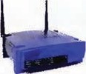Homewireless router Forbiddenwords: Wireless, Router

June
July August
September October

Week
Workstreams
Terms and Conditions Contract Signature Design Ph e
Migrate to New System
Testing Period Project Handover Sign Off
Steady State
1 2 3 4 1 2 3 4 l 2 3 4 1 2 3 4 1 2 .3 4 i , 2 3 , 4

78 I Partner Fiie B

UNIT 4,Exercise17 File s
1 Call Student A totry and solve a technical problem. Answer Student A's questionsusingthe
Information below. You can give your own name, email address and phone numbers.
- Your ticket reference from when you first reported the fault is 7708.
- The problem you have is that you cannot send or receive emails.
- You have power.
- Your Ethernet cable is connected.
- Your LAN hub isn't working.
- Your network cardis OK.

2 Now Student A will callyou to try and solve a technical problem.Ask questions to complete the trouble ticket below. Decidewhether to close the ticket or leaveIt open for further investigation.
UN T S, Exorcise 11 File 7

Complete gaps 5-8 in the text on page 43 with the words below.
pharming spyware keylogger ldentity theft
Now ask your partner questions to complete gaps 1-4. For example:
Whatisthedifference between a virus and a worm?

UN T 6, EXERCISE 13 File 8

You work for ThaiManagement. Student A, who works for the Bangkok branch of the estate agency Maxland (see page 48), has come to see you to discuss managed services.
Student A only wants some of the features of the Gold Service (see page 49).After discussingthe matter with your boss, you havedecidedthat each feature of the Gold service isworth a monthly fee of

Big Oil Network Fault Management
Summary of Problem Headset
Telephony Application on PC
IP address Headset Volume Trouble Ticket
Trouble Ticket Number 2003

Damaged I Undamaged Locked Up/Functioning

On/Off Open/Closed
6000 Thai Baht.
Role play the negotiation to get:he best price for as few services as possible.

UNIT 7, Exercise 20 File 9
Sketch a homepage for a website that relies on subscriptions for itsincome. You needto make sure that visitors will want to stay on the homepage and let them know that there are ad\'antages to signing up and payingthe subscription.

UNlT 5, Exercise 7 File 6

You are the representative ofData Safe and Sure, a data centre services provider and have been called to a meetingwith Student B, the IT Managerof VCVQ, a small but growingVenture Capital company. Answer Student A's questions, You needto find out:
- how secure their data is at the moment.
- what would happen if there was a fire I flood I break-in I hardware failure orloss of power or communications.
- explain the advantages of usingyour data centre which has been purpose built.
Once you have enough information explainthat you have two basic offers:
Fullservice
You host and manage alltheir applications and data and provide a service monitoringservice 24/7 and 365 days per year. This costs £1000/GB per annum Back-upservice
You keep an up-to-date copy of their data in case they have a problem. A remote backupis done once a day that costs £50 a week for no more than 1GB of data backed up.

s6 I

Transcripts

UNIT 1, EXERCISE 11

Device Manufacturer
a To be honest we don't know what to do these days. We used to make cameras and went digital. But then everybody wanted good camerason cellphones, so we started makingthose, but people are always wanting to upgrade and get the latest models or new gadgets.
Iwent to a technology fairlast week and theywere demonstratingthisjacket and hatthat was your phone. There are so many disruptive technologies, Idon't know what's goingto happen. Maybe we'llhave to get into clothing.

TVBroadcaster
3 A lot of broadcasters like usare havinga hard time.The problemis that there arelots more channels these days and people also get them throughdifferent media. Ican download the latest films from the phone company. My children don't even watch TV. They watch video online and their friends sendthem clips on their mobiles. But we have to survive onour advertisingrevenue and at the moment that's falling. Thingsare really not easy, and
I'msure there are some broadcasters that will go out of business.

Software Manufacturer
4 We manufacture software, and we are doingreallywell at the moment -the telecoms service providers and telecoms equipment companiesjust can't compete with us. I mean,what's the pointof havinga phone on your desk nowadays whenyou can pluga headset into your computer and anapplication does allyour voice telephony for you-and often for free? With a desktop computer, IPconnectivity, and a headset, you don't need any PABX or all that voice cablingaround the
building or expensive maintenance contracts and so on. That's why our businessis growingso fast and as far as I can see, it's likely to continue.

Search Engine
s We runa search engine,so we're in a great position to take market share from boththe software and hardware industries. What's the point in buyinghundreds of software licences if your employees canjust come to
us and use one of our applicationsonline? We provide
security, we maintainand update the applications, we do all the data storage, archiving, and backup.
Companies don't need to rundata centres anymore, we do that. Employees don't need expensivelaptops or desktops with gigabytes of RAM. They just need Internet access devices on their desk or in their hand. They can access the applications and data they need to from anywhere.

Fixed Telecommunications Networking Provider
6 We own the fixed telecoms network, and we've seen a big fall in revenues from vo ice calls because everything
is IPnow. Butin fact we're now in a great position because we are putting intelligence into our network so that it can become an enormous computer, capable of delivering applications. Allour customers need is a
broadband pipe into our network cloud and we act as an lT util ty-and most people have already got that withan ordinary phone line. With the new capabilities we have. we can provide TV, software, Internet access, email, teleconferencing, all sorts of things-and that easily makes upfor the money from traditionalvoice calls.

UNIT 1, EXERCISE 16
? It's very difficult to predict exactly how technology
1 developments willprogress anc indeed some of these predictions may have already happened bythe time you listen to this,and some may stillbe a tong way off.
What we will definitely see over the next few years is a very high rateof change because of the convergence
of technologies. Convergence is far from over. The next
twenty years will see much more of it, and the whole of IT willconverge withthe fields of biotechnology, nanotechnology, and cognitive technology.The result is thatcompanies in everyindustry sector will see
enormous changes. There will be great opportunities and of course great dangers as we ll.
lf welook at telecommunications, today's trend for massive increases in bandwidth into people's homes means that providers will create different business models,so voice calls -anda lot else-are likely to
be free in thevery near future, say 2011.As for mobile techno logy, mobile phones have come from nowhere in thelast ten years and now they are everywhere; but they'll probably disappearin another tenyears.
Instead of mobile phones we will probably have their funct ionality builtinto thingslike jewellery or patches, andinformation will be displayed on contact lenses. These could become available by about 2020.
The software industry is very likely to see bigchanges. Windows'market share will fallbelow 50%-perhaps asearly as 2011and definitely by 2015. We willalso
see software delivered asa service, and this will slowly become the norm. At the same time there willbe big developmentsin hardware. We will see chips with
ten billion transistors and theywill lead to desktop computersthat can compute asfast as the human brain by 2017. Forget the keyboard and mouse or evenspeech recognition as a way of inputting data. The next big development will be thought recognition, and that may beviable some time around 2025.

Transcripts I 87

In terms of business, we may see paper money replaced bysmart media as early as 2011.The technology
is already there, but people or banks may not feel comfortable with It. Manufacturing,logistics, and retailing arevery likely to replace all barcodes with RAD technology in the 2011to 2015 timeframe.
And what willsociety took like in the future with all this digital technology? In some countries there is already a tot of surveillance and we arecertainto see this grow
into most neighbourhoods by 2014. And assurveillance in the realworldgrows, we'll see more and morevirtual reality, but that too will bring its own problems, and virtualreality escapism may start becominga social problem around 2015. Most societieswill have ID cards by 2016 but even these will probably be replaced by biometric scanningwithin a few years of that, so anytime from 2020 onwards.
So, it is clear that things like five-year IT investment plans for business are becomingalmost pointless because things are changingso fast. Companies must learn to be adaptab le: adaptability will be the main quality for survival,while goingfor efficiency today can lead to death tomorrow.

UNIT 2, EXERCISE 1

always knowswhere Iam. I'd like to be able to do all these things on the move or if I'm workingfrom home.
Kate OK well.for a mobile professionalsuch asyourself, the two mainoptions that you have are either a mobi e phone and a
wireless laptop or a handheld device such asa smartphone. These are better than the old PDAs,which of course can't do voice.
It really depends on how much weightyou want to carry around and how often you create documents or do significant work on them out of the office.
Antonio Idon't mindcarryingaround somethinga bit heavier as long as Ican do everything I need to do. Ioften have to create or amend documents or presentations when I'm away from the office, that's important to me.
Kate OK,what Iwould recorimend is this. For your voice requirements I'd go for this SuperMob 360 3G phonewhich is GSM and GPRS enabled forvoice, data, and
location-based services. It also has an email application on it and i:'s internet enabled so you can also browse tie internet.1gigabyte of data transfer per ml)nth isincluded for
the first year. More importantly, you will be

Kate
8 Antonio

Kate

Antonio

Kate

Antonio
Morning, how can Ihelp you?
Ineed some suggestions on updatingmy mobiletechnology.
Tell mewhat you use at the moment and what you need to do and I'm sure that I'llbe able to recommend somethingappropriate. Well,Irun my own small businesswhich has been goingreally well. I'vegot an old desktop and a GSM phone. The problemis that I'm on the move so much it's notvery convenient only beingable to access all my Information when I'min the office. Ialso have to make two or threelong conference callsa week. The battery on my phone
quite often runs out after these and it's a bit embarrassingcharging my phone in a customer's office and it's notvery professional.
That shouldn't be a problem. The battery life of devices these days is prettyimpressive.
What sorts of tasks do you need to be able to do when you're away from the office? Well,obviously, Iwant the basic functionality of my current phone. So to
be able to make and receive voice calls and voicemail,conference calls, and so on. Isend and receive emai sall the time and sometimes Ineed to be ableto read the attachments.Itwould great if Icould access the database we have at the office
just before Imeet a client to check how their order is progressingso Ican give them up­ to·date information.Also, Ineed to update my calendar on a daily basis so that my PA
able to access that database at your office to download customer orders. Actually, you could also use it to keepyour calendar
up-to-date as itcouldsynchronize with your PA's desktop automa:ically. It has a battery life of eight hours anda spare so you should be able to go allday without needingto recharge, even withleong conference calls. All the SuperMobs ato have GPS soyou'll be able to find your ct:ents easily. There
are now tots of applications you could download toit, deperdingon what you need.
It would also be worth gettinga laptop such as this Silver Lite A2 and use that instead of your desktop. A full keyboard will be much easier to use than the tiny keys on a handheld device. Ithasgot wireless broadband and is WiFienabled so you can use it incoffee shops, trains, or airports. It has also got Bluetooth so it can communicate with the phoneif you ever needed it to. It comes with all the applications you need to work wherever
you are. And at 2.5kgit's one of the lightest laptops on the market.
Antonio Wow, that all sounds great. Iwish I'dcome in sooner. I'lltake thc:t combination please.
Kate Great, I'lljust check onthe system to see ifwe havethem instock .One second. Oh dear, I'mso sorry we haven't got anyin
stock at the moment and Idon't know when the next delivery is. I'msorry.

88 ITranscripts

UNIT 2, EXERCISE 5

But for us, as retailers, ifwe know where someone and theirsmart phoneare, we can

Malcolm
9
Bob
Hithis is Malcolm; pleaseleave a message
after the tone. Malcolm,it's Bob.
Look, lam really concerned about thelack of investment in the technology we havein our stores and thisis causingus real problems. Mysates staff are tryingto sell our products to our customers without knowingwhether they arein stock. They are spending alot of time tryingto find things in the warehouse that are actually out of stock. And we can
see when popular products are runninglow butwe haven't go an easy system to reorder and restock.
We can't see what's goingout and what's
comingin,so we haven't got a clue what's goingon. We do not know which suppliers are goingto be deliveringgoods and on which date. We havelorries from the distributioncentre turningupat the store warehouse unannounced and we have no ideawhat inventory they are delivering, so we have to unpack it allto find out what it is,before we can store it in the warehouse. And because we are not sure what we are supposed to have in stock, we can't check to see if anythinghas beenlost or stolen.
And thenif we do manage to sell something andit is in stock, our next embarrassment to tryingto work these old tills. Haveyou any idea how stupidwe look sellingthelatest smart phone orlaptop and then having problems at checkout because the tills don't work? You should see the queues.
And it gets worse. While my staff arelooking

Antonio

Presenter Antonio Presenter

Antonio Presenter

Antonio
figure out which businesses and services they are near. lf we also know what the user likesor dislikes, we can show or recommend places to them on their smart phone screen. This is known as GeoMarketing.
So if, for example, Isold high quality pizza, and the customer was registered
somewhere as a pizzalovers then myshop would show up on theirsmart phone map? Yes, that'scorrect
Cool. So how does that work then?
Wellthelocation of the mobile device is calculated by timingsignals sent by
satellites to the mobiledevice. Its distance from the satellite can be calculated bythe transit time of the signal. Compare the distance from three sc:tellites and you can calculate the actual location of the device to within about 16 metres. OK so far?
Yes.
So if the moblle provider or another service provider has a database ofinformation detailing what the customer is interested in,perhaps this is a service the customer subscribesand inputs to, thenwe mash
up that data with the !:>cation of the device and look at which retailoutlets,hotels, restaurants, etc. the device owner may want to know about. The GPS locations of those can beshown on a map of the local area displayed on the device screen and the user can go to them if they Nish.
That sounds great. Where do Isign up?

for itemsin the warehouse, customers have
UNIT 3, EXERCISE 4

to wait and some just walkout. The shop floor staff are also havingto answer the phone,which is ringingall the time,when they shouldbe servingcustomers.
Look -wearelosing sales because we do not have the right goodsin stock and our customers receive a terrible level of service. We're goingtolose customers to our competition,Bob,if we don't sort this mess out soon.
Theirony is, Bob, we are a technology
retailer and yet our own technology is rubbish.
Can you let me know what IT isgoingto do
about allof this?

UNIT 2, EXERCISE 12

Elizobeth

"
TalkingSoftwareis anSME·sized software development company. We have three areas of expertise. First, we have about five Business ProcessConsultants who
can analyse what business processes exist in each Cleverbox and Smart Route
department. Thisanalysis is the start of the software development process and provides a specification or Software Requirements Analysis.
Secondly, if Cleverbox want usto develop
this Software Requirements Analysis into some new, bespoke software for you, then we haveapproximately twenty software engineers, programmers, and codersin our Software Development team. These people take the Software Requirements Analysis and use it to design the software

Presenter
10
So,asyou know most smart phone.s these
days are GPS enabled so their location can be monitored. This isuseful for navigation and mappingor trackingyour workforce.
architecture and code and compile the software. All of their outputis designed to be robust, modular, secure. and of course

Transcripts I 89

thoroughly tested for bugs.If you don't Elizabeth
need a bespoke solution, then they could customize an existing software product to fit your needs.
Thirdly,we have a ten-strong Application Implementation team. Led bya Project Manager. they willwork with Cleverbox to manage the successfulImplementation of any new sortware. They could install the bespoke software we have developed, they could install a customized product, or they could implement an off-the-shelf package
too. As the rollout of software across a Mustafa
business is socomplex, they design and work to a strict project plan to make sure that the cutover to the new software is a success and we won't sign off the project
untileverything is ina steady state. Elizabeth

UNIT 3, EXERCISE 12
Thanks Pedro. Once this is completewe will start the cutover tothe new software, department by department, startingwith
Finance. On the first Monday of each month we will putin place a data freeze on your old application.Approximately one week
later we willbeginthe data migration which wllltake about five weeks per department. Then testingwill begin.Testing and problem resolutionwilllast about four weeks then that department will be cut over. Any questions?
It's Mustafa here. We have to migrate the data startingonthe 8" of April.That would be general ledger and payroll for us. Can weinclude cash management and accounts payable?
Yes, Mustafa, they arewithinscope so it's OK. That reminds me I'anyone has anything that'sout of scope then we can fast track
a change control aslong as we receive the

Jane
12

Elizabeth

Jone Elizabeth
Hello everybody and welcome to the ERP
Rollout kickoff call.We've already signed Chuck
the contract with Talking Software and have
identified you as relevant stakeholders for Elizabeth
thiscall.I'll pass over to Elizabeth to explain
the project. Xu
Hieveryone. OK I'dlike to explainthe next nine months when wewill be rollingout the ERP software across the Cleverbox business units. Stickingto these dates is a
criticalsuccess factor aswe do notwant any Elizabeth
slippage. First of all,Jane, Iunderstand you
own IT Infrastructure with the MPLS network Sandro
required to bein bythe 17'h of Feb and the Datacentre ready by the 22"" at thelatest.
Any delay herewill be a bottleneck for the Elizabeth
entire programme.Ihope that's OK.
That's fine. Jone
Great. Pedro will liaise with you all to ensure data and software templates for each department are completed on time and within spec. Pedro, would you mind explainingthe workstreams involved?
request bythe end of March.
HR here. Will our data freeze from May 3"' mean we have to stop hiringpeople?
No, Chuck, you can input new employee's data straight into the new templates.
Hi. It's Manufacturing.The testingbetween August 181 and September 24•hwhen we cut overis averyimportant dependency
h
for us. Canwe extend thetest period until September 301h?
I'msorry. I'm afraidwe can't Xu. We can't afford any slippage at all.
Elizabeth, it's Sandra. What about ifwe
want to cut over early.before our deadline on August 23rd?
Sandra,that's fine ifyou are happy that the testingis complete an you've signedit off. No morequestions? O< then. In terms of governance we willha·1e a stakeholders'
call like thisoncea month to make sure we deliver a successful handover on the 29•hof October. Thanks for your tfme.Goodbye.

Pedro
Sure. Firstof all,we need toidentify all the data that you each have to migrate to the
UNIT 4, EXERCISE 2

new system which Iwould like at theend Dove
of this month.Then each department will 13
construct a data template in the software,
this needs to be done before the endof next Jerry
month. This will helpto remove any dirtyor unclean data from beinginput to the new system.
After that,the database will beconfigured to accept the template and data on the 15•h of March.Finally,any customization of your templates or processes must be completed one week later.
HiJerry. Africa now,is it? Sowhere are you and how arewe goingto talk to you this time?
Well I'msharinga Sat phone right now with Mgumba, our local guy. We're in the Upper River region.We've been travelling around tryingto figure out what telecoms infrastructure ls available. What we have found out is that West Africa Is connected to Europe via the South Atlantic 3 West Africa Submarine Cable which hasa capacity of120 gigabytes. The nearest cablelanding point is over the border.

90 ITranscripts

There are microwave radio links from there to here. The country is also connected
internationally via satellite and Intelsat Earth Station 1.So there are redundant connections and servicescominginto the country. Some of theinternational data network providers are starting to look at expandingtheir networks here and putting some nodes in the capitaland the other main city. Sowe may beable to get MPLS or global Ethernet services in the future.
Dave So Mgumba,what's thein-country infrastructure like?
Mgumba Historically,in·country, we have hadpoor
UNIT 4, EXERCISE 14

Greg Hi.Is that Florence?
14 Florence Yesit is.
Greg Florence it's Greg from the NOC in London. I understand you've got a problem as I've got Trouble Ticket 2574in front of me.ls it OK to talk now and on this number?
Florence Yesit's fine. I'velost myvoice and data connectivity to my desktop, that's why I'm usingmy mobile.
Greg OK Florence. What I'm goingto do iswalk you through a series oftests to see ifwe can locate the problem.ls that OK?

 | fixed line infrastructure. A second national  operator was licensedin May givingus | Florence  Greg | Sure. Fireaway.  OK. Can you just confirm that you have
 | some choice instead of just the PIT.The |  | power at your desktop andwithinthe office?
 | country's electricity utilityis alsolaying | Flornce | Yes, I'vechecked that. -he PCis on and
 | fibre and leasing capacity to telecom |  | everyone else is OK sowe have power.
 | operators. To its credit, the PIT is rolling | Greg | OK. Next can you look at the back of your
 | out a national fibre backbone to serve the |  | PC and check that theyellow Ethernet cable
 | existing local telephone exchanges. In the |  | is plugged in to the port on your PC and
 | mountainousregions they are erecting |  | followingthat check it i> plugged into the
 | point to point microwave towers as it saves time and is much cheaper toimplement. The | Florence | RJ45 connector on the wall.  Holdon....Yes, they're Joth fine.
 | telephone exchanges are mostly electro­ | Greg | OK. Good. Now, after that, Ihaveto check
 | mechanical but they are phasingthese |  | the LAN hubis functioningbutas you said
 | out and puttingin e.xchanges with digital switchingequipment. Copper fixed lines are |  | everyone else is OK, sothat must mean the  hub is functional.
 | being rolled out. So there's alot goingon at |  | So the next step Florence, isthat Ineed
 | a national level but teledensityis still well |  | to test the VPN network from myend, so
 | below African average. |  | holdon while Ido this ....That's tested OK
Dave | Jerry, what services can you get to the |  | and Ican see the router on my network
Jerry | office? What about the local loop? Well,our office is about 25om from the |  | management application so that's all  workingfine.
 | local exchange. So we shoulddefinitely | Florence | So Greg,ifthe WAN wo·ks and the LAN
 | be able to get PSTN and dependingon the switchingequipment In the exchange and quality of the localloop,possibly DSL.All | Greg | works, it looks likeit's somethingto dowith  my PC?  You're right as my next step is to remotely
 | thelocal loops are copper twisted pairand |  | check the network cardonyour PC. Let me
 | the lead times are really long. There will |  | try ...Ican't,it's not responding.It's your
 | not be fibre available to the customers' |  | network card. Florence, can you reboot your
 | premises for atleast two years. The problem |  | PC for me please.
 | with the copper pairs in the groundis that | Florence | OK.One second...OK it's coming back now.
 | they get dug upand stolen so we will need | Greg | OK. Let me dothat testagain.Yes it's
 | to ask that our services are provided using |  | working. Ican see you now andyour IP
 | telegraph polesand terminated straightinto |  | address is 10.223-44.867. I'lljust check that
 | mysecond floor office window. It should |  | with a pingtest. Yes that's successful.
 | support our voice and emailrequirements. | Florence | Great. Ican see that myemail is coming in
 | The other option of course is to puta VSAT |  | now and I'vegot connectivity.
 | dish on the roofwhich would probably | Greg | OK, thelast step is for me to just do a round
 | provide better reliability,but Ithink we need |  | trip delay test and confirm that the latency
 | to apply for a licence via the landlord and |  | is acceptable. Hold on.Yes, its 75mS which
 | that could be really expensive. |  | is underneath the threshold. Florence, if it's
 |  |  | OK with you, I'llclose the ticket.
 |  | Florence | That's fine. Thanks so much Greg. Bye.

Transcripts I 91

UNIT 5, EXERCISE 1

Good morning, and welcome, my name is Helmut. First
1s I'lltell you a little about our data centre, then we'll have a tour inside the data centre and then back to this meetingroom for a Qand A session.
So we are a Tier 4 data centre providing 99.995°/o availability for your mission critical data and applications. That's only 0.4 hoursdowntime per year. As you noticed onyour way here this morning, we are deep in the Bavarian countryside away from any airports, flight paths, or terrorist targets, and
on a raised plainto protect usfrom the potential of flooding.As you have just experienced, we have strict security procedures to get into the site and then further restrictions on movingaround withinthe site such as fencing and barriers; we have 24-hour security guards and CCTV. Our own employees have to gothrough that
security every day and they must use biometrics to move between the compartments in the data centreitself.
There are no exceptions to all of this security.
In terms of power, we have two separate power feeds from the grid, coming in from the east and the west, alongwith our own UPS systems and generators on site. We also have boxesof candles for when the lights do
at the rear of the cabinets and cold aislesat the front of the cabinets. This helpsto minimize hotspots. Also above us are the smoke detectors and clean agent fire suppression units, shoulda fire ever break out.
All the equipment, the servers, blades, etc.are housed in 19-inch racks which are mounted floor to ceiling.For all that data we haveabout 15,000 racks holdingabout 300,000 servers. You can see the front of the blades in the racks here.Any alarm conditions are indicated by
the front panelLEDs butalso in our management centre. Technicians can also use CDROM, disk, or USB portsto carry out any local maintenance or back-up tasksfor individual servers.At the back here you can see all of the Ethernet portsthat connect everything. These are the fans that pump out all this hot air.Here you can see the power supply for the racks and blades.
We of course provide all of the servers for your use but some clients do provide their own which we collocate and manage for them accordingto their own bespoke SLA. Most of the applications we host here for clients are ERP and CRM systems butthere are all sorts of applications hosted here for all sorts ofindustries.

UNIT 5, EXERCISE 5

go out. Ha Ha. Only joking.To ensure we have resilient communicatio ns connectivity, our telecoms services come into the north of the site and the south of the site from different network POPs andwe use two different carriersto ensure full redundancy and separacy. This more or less guarantees that we do not suffer from network outages.
Soyour data will be protected from plane crashes, power cuts, network outages, bombs, and to a certain extent malicious employees. We have, of course, eliminated any single pointof failure to protect ourselves and your data from those crazy guys in the diggers.

UNIT 5, EXERCISE 3

So we are now inside the central apparatus room. As
16 you saw, Ihad to use my fingerprint on the scannerto get us in here,which Iam authorized to do. Only certain employees are authorized to bewithinthe data centre itself.
We have here 200,000 square feet of data centre and a capacity of 200 petabytes of data, that's the same as all the printedmaterial in the world. As you can see we are standingon raised, perforated tiles. Underneath these are the telecom cable trays carryingallof the CAT6 and Ethernet cables.Also below usare the power cables
that serve all the equipment. Above us in the ceilings we have our extraction and cooling systems to allow us to maintainthe correct temperature and humidity specified by the equipment manufacturers. We have to ensure
that this environment ismaintained 24/7 and 365 days a year. We have designed the layout to have hot aisles
qy Rupert
17

Helmut

Rupert
Well,Helmut, that was a very impressive tour of your facility. Butyou know outsourcingour data to a third party is
a very serious decision.There are a few things,likewhat would happen when youdo go down for that 0.4 hours per annum? What happens if that is duringour tradingperiod? Well,we haven't had an outage sincewe have been here.We monitor everythinghere 24/7 at our management centre which you can see over there. Bli if there was a comms outage we would switch to the back-up servicewithout you losing service. We have fully redundant services into the site so
we'd usethese. We would contact the PIT, who we have a very strict agreement with, to carry out fault findingand rectification. Our SLA with them is for a one-hour break fix. If welost power, our own back-up power systems wouldstart and we wouldn'tlose power at all. If there were a problem with the cooling systems, our managers would see alarms about that beforeit affected
the equipment. In the event of one of your servers goingdown, our managers would see alarms goingoff in the management centre and they woulc'. isolate and change out your equipment straight away. Your downtime would be amatter of minutes. OK, that all sounds fine. But worst case, you've got all ourdata, supposingthere
was an earthquake or you got hit by a plane, what wouldhappen then?

92 I Transcripts

Helmut

Well look,no system isinfallible,we cannot protect against everythingbut perhaps I should explain,we have a complete mirror of this site in Switzerland. So all your data is backed up at that site. Soif the worst came to the worst, atleast there is acopy of all your data in another place. Shouldanything terrible occur, you would need to have standby communications links to our site
in Switzerland and you would be OK. Ifthat were to happen,you would switch over to the hot standby site and wouldcontinue to trade.

details.These then allow them to hackinto the bank'sdata centre and steal thousands of
people's account numbers and sell them to other gangs.

UNIT 6, EXERCISE 9

® Chen OK everyone, we need to decide which
19 managed service offeringwe need to
support our technology and what our Service Level Agreement should be. That's SLA, right Betty?
Betty Right, SLA.

Rupert Ah, great. At least knowing that, Iwould be
able to sleep at night.

UNIT 5, EXERCISE 8

A I'mwhat they call a white-hat hacker. I've worked
18 for the bank for about five years. Iwas in the IT department responsible for the firewalls and encryption software.But Ireally like programming and when the bank hada few hackers startingto penetrate the network Igot involvedin keeping them out.
B So, a white-hat hackeris a computer hacker, but when we expose security flaws we let the organization know they have a problem, rather than exploitingit. We fight against black-hat hackers-criminalswho will exploit these problems.
Anurak couldyou explainthe options for us?
Anurok OK. Since welooked at the adverts I have spoken to ThaiManagement to
understand some deta'lsabout each of the propositions.The Bronze Service offers us a maintenance response time of the next
workingday and the helpdesk is available 9 to s Monday to Friday.
Betty Anurak that's not goodenough for us. It's vital that we have cover seven days a week.
Anurak Yes, Iagree. And the sc:me goes for the helpdesk, because we're very busy Saturdays and Sundays with people hiring cars at the weekend. We need atleast the Si ver Service with the helpdesk available seven days aweek. But Ithink we actually
need the four-hour resoonse. 24/7 helpdesk availability like the Gold Service.

c | For example I'll runa"pingsweep" on a bank's network to see who is connected and then do | Betty | Lookingat this, it's the same for fault monitoring. It's important that we haveit
 | some TCP/IPfingerprintingto find out what |  | 24/7 like the Gold Sel'\'ice ,butwe don't
 | operatingsystem people are using. Imay then run |  | need a dedicated tearr to do that. So really
 | a sniffer which willwatch out for their passwords |  | we want to have the cl-eaper shared team
 | asthey key them in. Now. if they aren't usingsay |  | for proactive fault moritoringas long as it's
 | 128bit SSL certificates.their dataisn't encrypted andthen Ican access the bank's network and data | Anurak | 24/7.  OK, goodidea. In terms of performance
 | centre and dowhat Ilike. Idon't of course; Itell the |  | monitoring, we couldgo for network-only
 | bank Ihave found a weakness or a userwho needs |  | monitoringwith the Si ver Service or
 | to improve theironline security. |  | network and applications monitoring with
0 | What would my advice be to people to remain |  | the Gold Service. Any views?
 | secure online? Make sure you are usinganti-virus | Betty | Let's just have performance monitoring
 | software and you download any updates to keep |  | for the network because that reallyis
 | out the latest viruses and worms. Use a personal |  | important. Our applications are pretty
 | firewall. |  | simple; Idon't thinkwe need It for them.
E | Never respond to emails that look like they are | Chen | OK,let'slook at the commercial aspects.
 | from the bank, you know, phishing.This type of |  | Reporting,what'simportant to us?
 | activity is becoming evermore sophisticated. | Anurak | Well,Idon't thinkwe can wait for a month to
 | spear phlshing is far more targeted, not just the |  | receive reports. If we have user or customer
 | blanket spam of a few years ago. These emails |  | service problems because of our technology
 | look like they really are meant for you as they |  | then we need to be able to see what's going
 | are relevant to your business area.The emailwill |  | on there and then.
 | contain somethingthatlooks like an attachment | Betty | Iagree. Ithink it'svery important that we
 | but actuallyit's a piece of malware like a Trojan or |  | can have realtime reporting like the Gold
 | a worm. Thissoftware will sit on a computer and |  | Service offers.
 | send the black-hat hacker personal information, | Chen | OK, what about a Service Manager? Can we
 | passwords, credit card numbers, bank account |  | share one or is it essential to have the Gold

Transcripts I 93

Anurak

Chen

Anurak

Chen

Betty

Anurak Chen
Service which includes a dedicated Service Manager?
Ithinkwe can go for a shared Service Manager in the Silver Service. Thiswill keep our costs down. We don't have that many sites to manage. As long as there's someone who's familiar with our infrastructure, then I thinkashared one wouldbe fine.
OK, fine with me. As far asthe asset buyback is concerned, I'd reallylike the cheque on day one, what a great offer!
But boss.that means we'dlose control of our IT. Iknow you'd like the money up front at the start of the contract but inmy opinion it's not as important as retainingcontrol over our technology and keepingit up to date.
But they are also offeringa technology refresh to upgrade the technology on an annualbasis. What about that?
Do we really need that - surely we'rein the best position to know what needs replacing? And we'd lose control...
Wei I'llthink about itbutit looks asif we want some of the Silver Serviceand some of the Gold Service.As far as the cost goes, the Silveris 16,500 a month ...we can manage that no problem, but the Gold is more than double ...Anyway, I'llsee what Ican do ...it looks like I'vegot a negotiation on my hands.
Chen Mo/iwon

Chen

Mo/iwon Chen

MoIiwon Chen

Maliwon

Chen MoIiwon

Chen

Maliwon
The only thingis that we do need theshared team 24/7, not just duringbusiness hours. Isee ...well...,no that's OK,we can do that at a reasonable price, but only ifyou also have a shared Service Manager.
OK, Ican accept that. Thank you. That's fine as we don't have that many sites and for performance monitoringwe only want the network covered.
Yes, of course.
For reportingwe requirethe Goldoffering of real time online. How doyou suggest we deal with that?
I'llhave to thinkabout that. Keep going. Well that leaves the asset buyback and technology refresh which, to be honest,we were undecided on.
Well Iwon't be able to split them. You have to have both or neither.
OK, Idon't havea problerr with that.
Well if youtake the asset buyback and the technology refresh of the Gold Service, then Icould contribute the realtime reportingto the deal. How does that sound?
OK, butwe can't afford to :>ay 35,000 Baht per month peruser. What can you do about that?
OKlet me summarize first You are taking the cheaper Silver Serviceelements for fault monitoring, performance monitoring and the shared Service Manager.And Gold
Service for all other parts •)f the SLA. How

UNIT 6, EXERCISE 10

Chen Thanks for coming in to see me. I've
20 discussed your offers with myteam and I'd like to talkyou through what we areafter.
Maliwon Have you hada chance to look through the different options?
Chen Yes, we've hada goodlook.

Chen Maliwon

Chen
would you feel about 33,coo per month per user?
Go to 27,000 and we havea deal.
OK, let's compromise, I'llmeet youin the middle at 30,000.
OK. Let's shake on that. Ifsa deal.

Maliwan Great, sowhich of the three do you think would suit you best?
UNIT 7, EXERCISE 11

Chen Well,based onour business requirements the SLA we arelooking for is a mixture of both the Silver and the Gold Service. Would you consider a compromise between the two?
Mo/iwan Well,why don't you tell me what you are after and I'llsee what we can do.
Chen For maintenance cover we require a four· hour response and 24/7 helpdesk aswe have people arrivingfrom the airport at all hours and if we have a fault, an eight-hour responseis just too long for us.
Ma/iwon OK that's not a problem, that's all covered by the Gold Service.
Chen Yes, but for fault monitoringwe only need a shared team, not adedicated team.
Moliwon We can manage that.
Laro
21 Anna

Laro Poul
OK,what are you here to pitch today?
We want to develop lamppost.com, a social networkingsite for dogs and theirowners. We need to raise $750,000 seed fundingto get us going.
Err, OK. Keepgoing
There are 72 million pet dogs in the US and therefore about the same number of owners. We have built a prototype that allows owners to input their street name. Lamppost.com presents a local map showingwhere nearby dogs and owners live. The owners can click on the dogthey
think theirdogwill get onwith and they can go for awalk together. There's also a local blog and messageboard on the site where owners can arrange groupwalksor if they are working,can ask for people to take their dogs for a walk duringthe day.

94 I Transcripts

Afan Anna
OK guys, how are you goingto monetize this?
Users register on the site for $1per year.
Thiscreates an account for them. We will have an ecommerce sectionwhere owners can buycollars, leads, food, etc.
sign up fee, then a $4 monthly subscription. Or people can purchase the software in a store for $J9.99

UNIT 7, EXERCISE 18

Afan Paul

Lara
Vets' Surgerieswill also advertise on the site usingbanners, which will be another revenue stream for us. We project two million registered users year one, five million registered usersyear two and fifteen million registered users byyear three. When users register they have to provide anemail address, soof coursewe can use these to form a mailing listthat has avalue.
And technically, where are you with this? We have boughtthe domainnamelamppost. com. We have built a prototype that we are hostingon our own servers at the moment. We've spoken to a third party hosting company who can provide dedicated
servers, internet connectivity, data backup, and archivingfor a monthly fee.
OK guys, thanks; we'llhave a thinkabout it.
Stuart
23

Paul Stuart

Paul Stuart

Paul
OK, so here'sthe mock·up of the screen so you can see the layout and get the look and feelof the site.
OK.cool.
So top left we have your logo. To the right of that, so the top centre and top right of the screen, we expect that space to be banners sponsored bycompanies that want to advertise on the site.
Great, yes, advertisingrevenue isimportant to us.
Below that, goingacross the screen, we
have a row of tabs that let you navigate the site. So Ithink the tabs wlll be Homepage then Social Networkingthen Blog then Products and finally tlews. Is that order OK?
Actually Ithinkwe wc:nt the Blogto be last, so on the right.J.lsowe want a tab for a resources page so that people can

UNIT 7, EXERCISE 14
©
Afan  Yuniko | OK guys, start your presentation.  Thank you. We arevideo game developers and require fundingto develop BIGFIGHT which will be a new, globally-networkedwar game. We are looking for start up fundingof | Stuart | OK, no problem. Soon the homepage tab we  have a block of text e:<plaining the service.  In the middle columnwe've got a couple of JPEGs of happy looking dogs and on the right of that, we have the sign up and sign
 | $2m. The game will be designed for all three |  | in buttons. But basically a very clear and
Tomas | of the mainconsoles on the market that have a broadband or WiFiconnection. But moreimportantly we will also be developingan on-demand networked version for PCs that have good enough  sound cards and graphics cards or even TVs that have Internet connectivity. |  | simple design ...Whei someone clicksto Sign Up, they go thro Jgh to a webform that they fill inwith teir details to sign up to the service. Obviously we will create an  ecommerce facility so they cansecurely put in theircredit card details for their annual fee.
Yuniko | The game willbe streamed across the 1.5 billion Internet connections around the | Paul Stuart | Great.  When they click on Sign In,then they are
 | world into users' homes. This enables  citizens to join in a giant battle representing their home countries,which we canidentify | Paul | prompted to put in their username and password.  And if they forget their password?
Tomas  Luke | from their IP address.  Gamers can jointheircountry's army and be representedin the game as a soldier. They can controlwhat the soldier does usingtheir keyboard and controllers or joysticks.  OK. What doyou need the money for? And what revenue streams doyou anticipate? | Stuart | They click on this button below:Forgot your password and we send a reminder  emailto the email address on the database. Once they are in, they can go to the Social Networkingpage and upload images of their dogor themselves, preferably as JPEGs but we could accept GIFs, and set their profile
Yunika | Well we have puttogether a team of game designers and opensource video game |  | details soother userscan see them. Once they have done that, they are live. Ifthey
 | developers. We think development will take |  | see a dogowner or a dog that they like, they
 | about a year and then six months of trialling and testing. So we need the money to support that development activity. In terms of revenues, online customers will paya $to |  | can click on the image and get a pop-up that gives further information. Or vice versa their detailswill pop up if they are clicked on.

22
download pdfs on products or dog health issues orwhatever.

Transcripts I 95

UNIT 8, EXERCISE 1

Presenter Good morningandwelcome to our
2 radioshow looking atTelecoms and IT andits impact on society. Today we are lookingat emergingdigital technology in Healthcare. We're goingto predict
how digitaltechnology might affect one patient's pathway of care In the near future. Let'simagine the case of Sue who has a suspected heart attack. We have with us Lynn, a paramedic, Malik, an A & E doctor,
a hospital manager, Imogen, and Helen. a cardiac nurse.

UNIT 8, EXERCISE 2
VoIPcall with the patient's GPto discuss anythingthey're not sure of before treating the patient.They will be able to do a 3D CT scan and transmit the hugeimage file to a remote specialist, say in London, and, using our screen sharingapplication, will be able to get a second opinion withinmoments.
All the hospitals will use the Digital Imaging and Communications in Medicine (DICOM) standard for handling, storing, printing,and transmittinginformation in medicalimaging which allows us to send anythingover any TCP/IP network, anywhere in the world
to getimages in front of the right medical expert.
Presenter So Helen, once the panicis over and Sue's condition is understood what will happento

25
Presenter | So let's start with Lynn, you're a paramedic  ...so what will happenwhen Sue starts to | Helen | her?  Iam a cardiac nurse,and Iwould look after
 | have chest painsat home? |  | Suewhen we receive her as aninpatient
Lynn | Well.when Sue falls illshe dials the |  | forobservation. Iwouldvisit her every day,
 | emergency services, speaks to the operator |  | and log on to the hospital systems using
 | and asks for an ambulance. We will be |  | my digital clipboard.The clipboard would
 | therein less than ten minutes as we all |  | recognize the RFID tag in Sue's wristband.
 | have GPS location equipment to work out  which ambulanceIs nearest to the patient |  | This taggingis a safegua1d to make sure we don't give the wrong drugs to the
 | and thenwe are directed to the patient |  | wrong patients. Icould give her tablets
 | automatically by the Sat Nav usingthe most |  | and the barcode reader on myclipboard
 | direct route. We rush her to the hospital, |  | would recognize and record the drugs I
 | monitoringher all theway. |  | was giving her. If Iwent to use the wrong
Presenter | And Malik,you are a doctor atA & E |  | drug, the barcode readerwould give an
 | Admissions |  | alert to prevent medoingthis. I'd also
Mollk | Yes, Iam. We willalready have Sue's full |  | take a few measurements, Input them into
 | patient records bythe time sheis brought |  | the clipboard which would then transmit
 | in to hospital. The ambulance will radio |  | this informationinto Sue's digital patient
 | her Health Number ahead, and with that, |  | records, so they are alwa·1s up to date.
 | all her details can be downloaded from | Presenter | And how about Sue's care once she's back
 | the National Patient Records Database |  | at home?
 | and Iwill receive all the information here | Helen | Sue wouldstill be monitored remotely
 | on my Mobile Clinical Assistant over the |  | at home. Shewouldputena monitoring
 | wireless LAN.This allows me to access |  | device every morningthat measures her
 | all information whilst beingas close as |  | temperature,blood pressure, respiration,
 | possible to the patient. |  | and heart rate. She would then plug it into
Presenter | Imogen, as the Hospital IT Manager,it |  | a broadband adaptor and the data would
 | sounds as ifthe hospital will be brimming |  | be transmitted to a database in the hospital
 | with technology. |  | and added to her patient records. The
Imogen | Well,the hospital will be connected to a |  | application wouldautomatically display the
 | national data network and huge national |  | data in a graph for the doctors to look at.
 | database holdingterabytes of every |  | The software wouldalso be programmed
 | civilian's medical records. The whole |  | to send an email alert to Sue's GPSurgery
 | hospital will bewireless-enabled so that |  | to arrange an appointment if her readings
 | with the correct security, actually a swipe |  | go over any thresholds orif the software
 | card and password, doctors or nurses |  | calculates sheis runningout of medication,
 | willbe able to access a patient's records |  | it automatically places an order for more
 | wherever they arein the hospital. They will |  | which will arrive recorded delivery before
 | be able to use their data tablet to set up a |  | she runs out.

